Abbey, George W.S.
Albaugh, James F.
Aldrich, Arnold D.
Aldridge, Edward C.
Augustine, Norman R.
Bolden, Charles F.
Brandenstein, Dan
Cabana, Robert D.
Callahan, Lisa
Campbell, Donald J.
Carr, Jeffrey E.
Carreau, Mark E.
Cazes, David
Chilton, Kevin P.
Coats, Michael L.
Collins, Eileen M.
Covey, Richard O.
Crippen, Robert
Culbertson, Frank L.
Dittemore, Ronald D.
Elachi, Charles
Elbon, John W.
Engle, Joe H.
Flynt, G. Allen
Free, James M.
Fuqua, Donald
Gerstenmaier, William H.
Geyer, Mark
Griffin, Gerald D.
Griffin, Michael D.
Grunsfeld, John M.
Hartz, Jim
Heflin, J. Milt
Hendershot, Cynthia
Hernandez, Jorge
Hieb, Richard J.
Holloway, Tommy W.
Hutchinson, Neil B.
Hutchison, Kay Bailey
Johnson, Sandra G.
Karas, John C.
Kavandi, Janet L.
Kerwin, Joseph P.
Kranz, Eugene F.
Kropp, Debbie
Lightfoot, Robert
Lunney, Glynn S.
Magnus, Sandra H.
May, Todd A.
McBride, David D.
McDonald, Vernon
Meyerson, Robert E.
Miller, Lon
Mitchell, Bob
Mulqueen, Mark E.
Nield, George C.
O'Brien, Miles
Ochoa, Ellen
Parsons, William W.
Pavlovich, J. Gregory
Pickens, Thomas B.
Readdy, William F.
Reightler, Kenneth S.
Schmitt, Harrison H.
Scolese, Christopher J.
Shaw, Brewster H.
Sirangelo, Mark N.
Stafford, Thomas P.
Staples, William A.
Stegemoeller, Charles M.
Stephens, Richard D.
Suffredini, Michael
Swallow, Edward M.
Thompson, David W.
Truly, Richard H.
Vantine, William
Wagner, Elizabeth
Whitesides, George
For Immediate Release
May 5, 2022
Media Contact Lindsey Cousins
281-480-2486
lindsey@baysidegraphics.net

RNASA’s 2022 Stellar Awards Winners Announced

HOUSTON, Texas (May 5, 2022). The Rotary National Award for Space Achievement (RNASA) Foundation honored the dedication of the space workers at the annual Space Awards Gala on Friday, April 29, 2022, by presenting the Rotary National Award for Space Achievement (RNASA) Stellar Awards.

Every year, the aerospace community anxiously awaits the announcement of the Rotary National Award for Space Achievement (RNASA) Stellar Award winners.

The 2022 Stellar Awards Evaluation Panel, Michael Coats, David Thompson, Dr. Sandra Magnus, Dr. Charles Elachi selected the winners based on which accomplishments have advanced U.S. space capabilities and hold the greatest promise of future capabilities.

Out of 111 nominations received, the Panel selected 18 individuals and 6 teams for recognition.

Prior to the evening's festivities, all nominees were treated to a behind-the-scenes tour of the Johnson Space Center and a luncheon at the Bay Oaks Country Club. Stellar Awards Committee Chair Jennifer Devolites welcomed the nominees.

Eileen Collins was the featured speaker at the Stellar Awards Luncheon. Collins was the first woman to pilot a shuttle, serving on Discovery’s STS-63 mission in 1995. Four years later in 1999, she became NASA’s first female shuttle commander, leading Columbia on a mission to deploy the Chandra X-Ray Observatory. She was the recipient of RNASA’s National Space Trophy in 2006.

Each nominee received a Fisher Space Pen donated by the company. The Fisher Space Pen was originally carried by the astronauts of the Apollo moon missions and is still used on manned space flights to this day. They are precision assembled, hand tested, and guaranteed to perform underwater, at any angle including upside down, in extreme temperatures, and of course in zero gravity. Each nominee also received a copy Eileen Collins’ recent book “Through the Glass Ceiling to the Stars: The story of the first American woman to command a space mission.” All the Stellar nominees had their photo taken as they received a special commemorative certificate with a United States flag that was flown to the International Space Station aboard the SpaceX-14 flight berthed April 4 through May 5, 2018.

The Stellar Award winners were announced at the RNASA evening gala on April 29, 2022 by astronaut Randy Bresnik and astronaut Dr. Jessica Meir who presented them with engraved marble trophies. The winners in each of the four categories, Early Career, Mid Career, Late Career and Team are:

2022 Stellar Award Winners in the Early Career Category

Dr. Daniel J. Kim of NASA Johnson Space Center - Outstanding technical contributions in the field of non-metallic materials for characterization of polymeric spacecraft windows and novel approaches to lightweight and robust spacesuit structures.

Courtney E. Mario of Draper Laboratory - Exceptional technical knowledge in developing autonomous vision navigation systems, dedication, and collaborative skills enabling the successful OSIRIS-REx sample collection maneuver.

Matthew Richmond of Northrop Grumman - Exceptional leadership of multiple Cygnus missions from assembly to integration, test, and launch campaigns.

Timothy E. Sauerhoefer of Collins Aerospace - Exceptional manufacturing engineering performance and commitment to safety and operational excellence on the phase change heat exchanger and CO2 removal system for the Orion spacecraft.

Abigail E. Sherriff of Barrios Technology - Continuous exceptional leadership in developing and implementing systems and data integration solutions for the successful operation and improvement of human spaceflight initiatives.

Brenton S. Taft of Air Force Research Laboratory - Outstanding contributions to developing new spacecraft thermal technologies and capabilities.

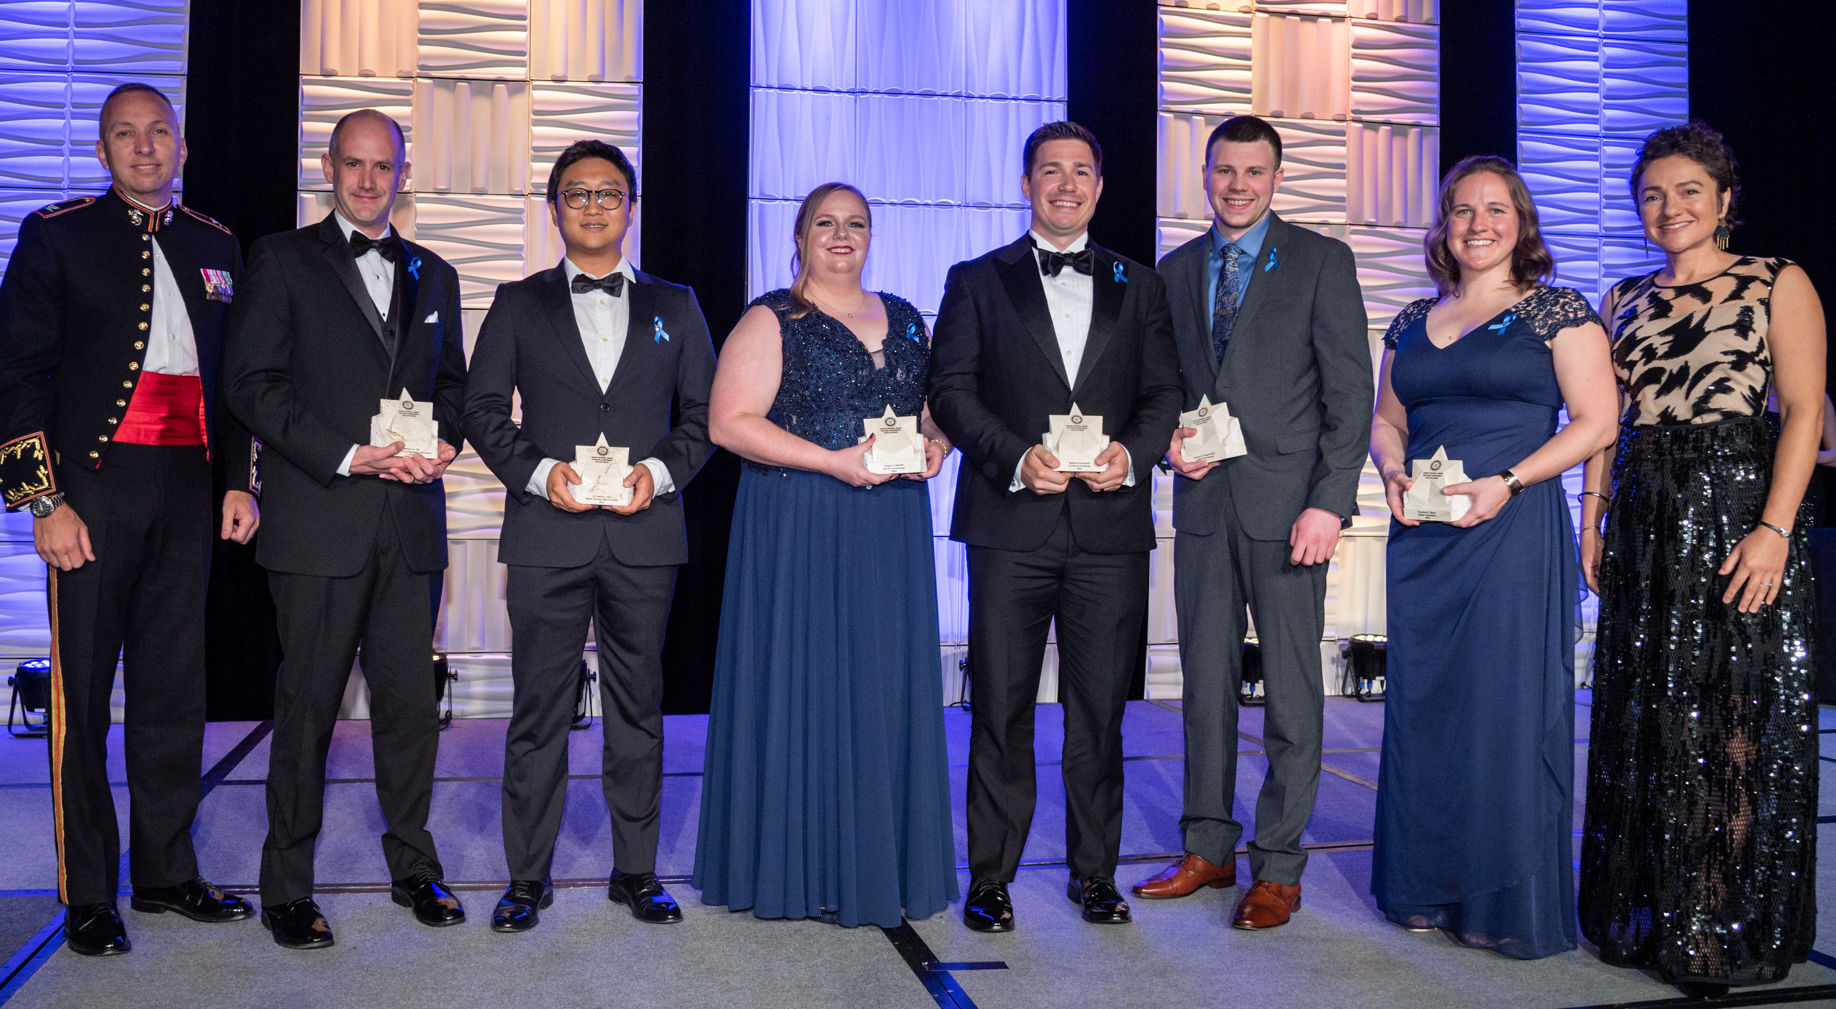Stellar Award Winners – Early Career. L to R: Randy Bresnik (presenting), Brenton S. Taft, Dr. Daniel J. Kim, Abigail E. Sherriff, Matthew Richmond, Timothy E. Sauerhoefer, Courtney E. Mario, Jessica Meir (presenting)

2022 Stellar Award Winners in the Mid-Career Category

Paul M. Brower of Northrop Grumman - Outstanding leadership in human spaceflight, including successful operations of the Cygnus spacecraft for ISS Commercial Resupply Services and the operations development of the Habitation and Logistics Outpost (HALO) module to Artemis Gateway.

Christoper C. Delnero of Lockheed Martin - Exceptional technical leadership and innovation architecting and delivering Thermal Control and Life Support Systems for Human Spaceflight beyond low Earth orbit.

Jennifer Deuling of United Launch Alliance - Masterful navigation of the Landsat 9 launch campaign, including integration of multiple secondary payloads which included a demonstration CubeSat dispenser.

Breeann Edris of Lockheed Martin - Exceptional technical leadership of Lockheed Martin’s Commercial Civil Space Program.

Ana L. Lopez of NASA Johnson Space Center - Sustained excellence and ground-breaking achievements in NASA human space flight communications operations, avionics and software, and space station research.

Dr. Michael J. Starks of Air Force Research Laboratory - Outstanding contributions in developing high impact space environment capabilities that protect spacecraft from their environments.

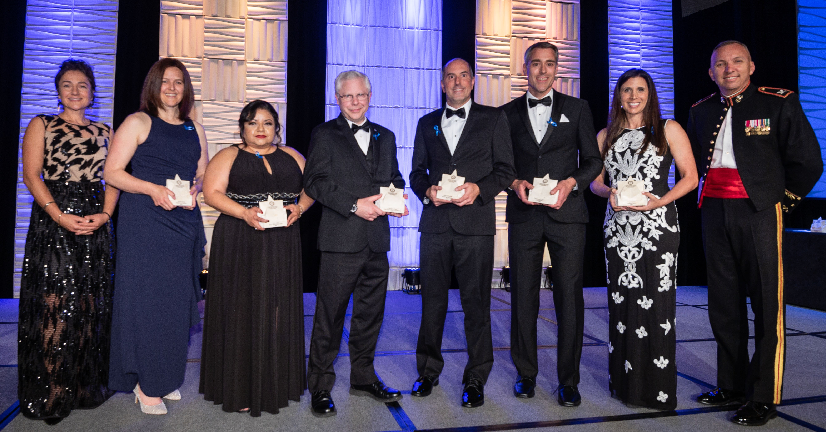
Stellar Award Winners – Mid Career. L to R: Jessica Meir (presenting), Jennifer Deuling, Ana L. Lopez, Dr. Michael J. Starks, Paul M. Brower, Christopher C. Delnero, BreeAnn Edris, Randy Bresnik (presenting)

2022 Stellar Award Winners in the Late Career Category

Bonnie Hattersley of Aerospace Corp - Exemplary space systems expertise ensuring that our most vital national security space capabilities are delivered successfully.

Mark Riedel of ARES Corporation - Instrumental support in the development and implementation of modifications to NASA’s integration efforts supporting the Japan Aerospace Exploration Agency’s (JAXA) H3 Exploration Transfer Vehicle (HTV-X) cargo vehicle and the Axiom Commercial Segment to the ISS.

Kenneth D. Ryan of Northrop Grumman - Profound expertise, insightful mentorship, and proven design solutions that have become the backbone for the avionics architectures of several Northrop Grumman commercial and human spaceflight spacecraft.

Steven Stich of NASA Kennedy Space Center - Exceptional leadership of the Commercial Crew Program leading to the highly successful SpaceX Demo-2, Crew-1, and Crew-2 missions to the ISS, restoring crewed launch capability from U.S. soil.

Karl A. Wefers of Aerojet Rocketdyne - Excellence in development and fielding of Human Space and Exploration Power Systems for 36 years.

Mark A. Zaffetti of Collins Aerospace - Lifetime of outstanding mechanical design contributions to Collins CSSS life support and thermal management hardware.

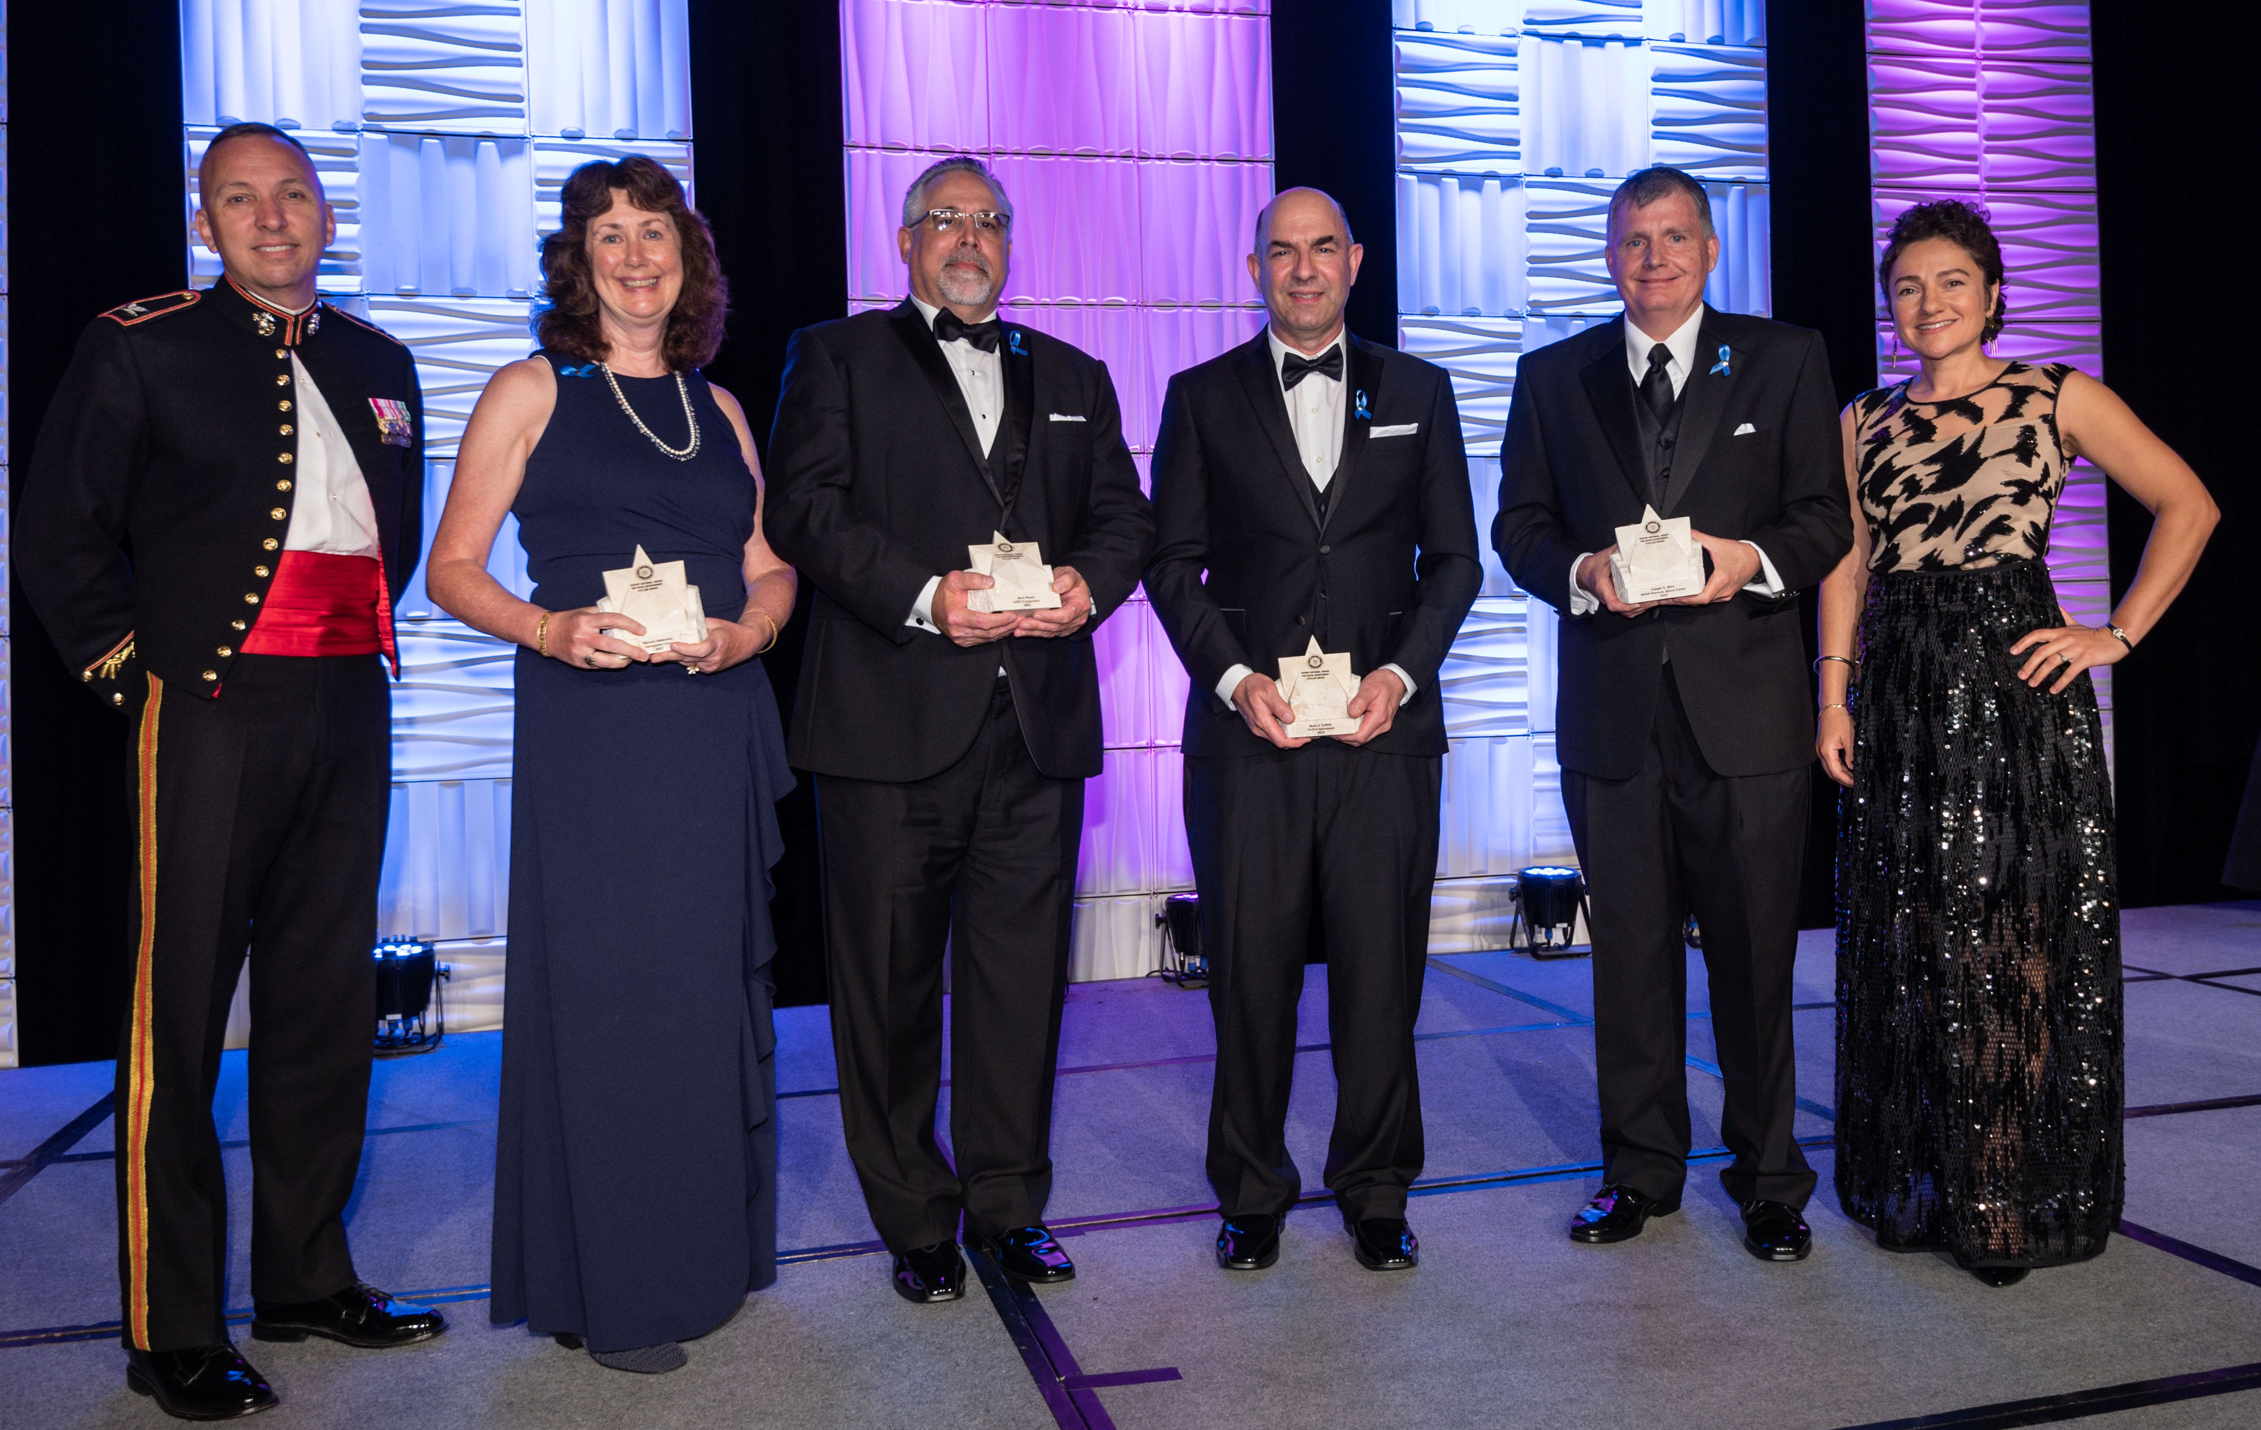
Stellar Award Winners – Late Career. L to R: Randy Bresnik (presenting), Bonnie Hattersley, Mark Riedel, Mark A. Zaffetti, Steven Stich, Jessica Meir (presenting). Not shown: Kenneth D. Ryan, Karl A. Wefers.

Stellar Award Winners – Team
Enterprise Engineering and Integration Team of United States Space Force - Outstanding engineering acumen in the development and fielding of classified strategic and tactical payloads for a $7.3 billion Secretary of Defense-directed satellite communications program.

Houston Support Group Multi-Purpose Logistics Module Troubleshooting Team of NASA Johnson Space Center - Successful leadership in diagnosing a Multi-Purpose Laboratory Module catastrophic hazard, and technical integration efforts leading to a successful MLM docking in the face of adversity.

Hubble Side Swap Anomaly Team of Lockheed Martin - Extraordinary efforts in side-swapping and recovering science operations on the 31-year-old Hubble Space Telescope, enabling continued operations for further scientific discovery.

Innovation and Prototype Division of United States Space Force - Successful advancement of the Multi-Mission Satellite Operations Center Ground System Enterprise to the Experimental Prototype Command and Control system.

ISS Mission Evaluation Room Managers of The Boeing Company - Excellence in leading ISS real-time sustaining engineering operations.

ISS Reboost Team of Northrop Grumman - Successful development of U.S.-provided maneuver services to counteract gradual atmospheric drag on the ISS.

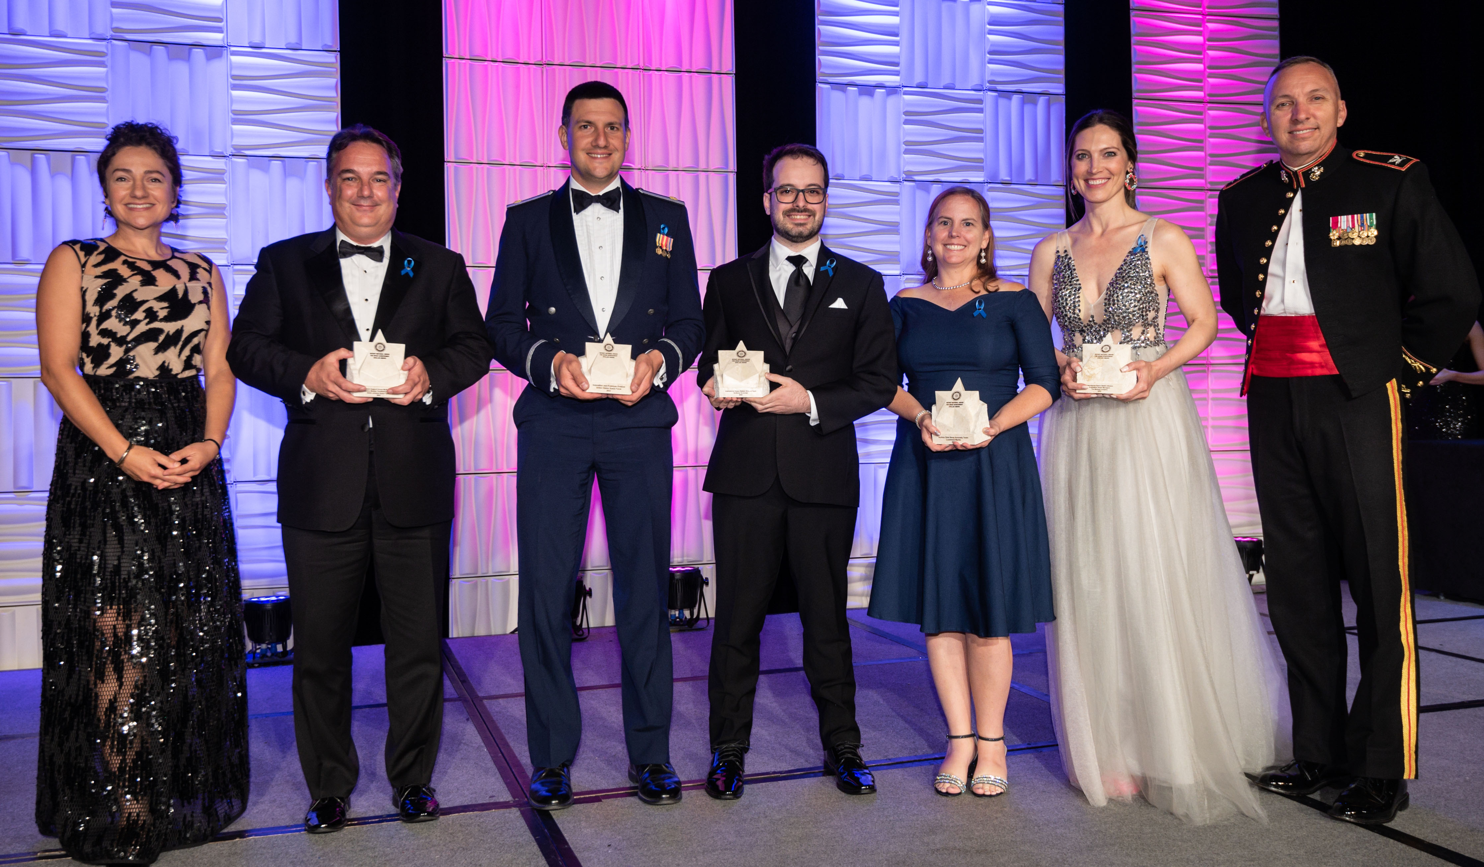
Stellar Award Winners – Team. L to R: Jessica Meir (presenting), Michael Campion (Houston Support Group Multipurpose Laboratory Module Troubleshooting Team), Maj. Travis Pond (Innovation and Prototype Division), Lucas Milgliorini (ISS Reboost Team), Morgan Van Arsdall (Hubble Side Swap Anomaly Team), Jennifer Hammond (ISS Mission Evaluation Room Managers), Randy Bresnik (presenting), Not shown: Enterprise Engineering and Integration Team

Visit http://www.rnasa.org/photos.html for images from the event.

The Rotary National Award for Space Achievement (RNASA) Foundation’s black-tie Gala on April 29, 2022, was recorded live, in its entirety, by Space City Films and is accessible on the website’s agenda page, www.rnasa.org/agenda.html.

About the RNASA Foundation: The Rotary National Award for Space Achievement (RNASA) Foundation was founded by the Space Center Rotary Club of Houston, Texas in 1985 to organize and coordinate an annual event to recognize outstanding achievements in space and create greater public awareness of the benefits of space exploration. The nonprofit Foundation presents the National Space Trophy and Stellar Awards each year. See http://www.rnasa.org for more information

