Abbey, George W.S.
Albaugh, James F.
Aldrich, Arnold D.
Aldridge, Edward C.
Augustine, Norman R.
Bolden, Charles F.
Brandenstein, Dan
Cabana, Robert D.
Callahan, Lisa
Campbell, Donald J.
Carr, Jeffrey E.
Carreau, Mark E.
Cazes, David
Chilton, Kevin P.
Coats, Michael L.
Collins, Eileen M.
Covey, Richard O.
Crippen, Robert
Culbertson, Frank L.
Dittemore, Ronald D.
Elachi, Charles
Elbon, John W.
Engle, Joe H.
Flynt, G. Allen
Free, James M.
Fuqua, Donald
Gerstenmaier, William H.
Geyer, Mark
Griffin, Gerald D.
Griffin, Michael D.
Grunsfeld, John M.
Hartz, Jim
Heflin, J. Milt
Hendershot, Cynthia
Hernandez, Jorge
Hieb, Richard J.
Holloway, Tommy W.
Hutchinson, Neil B.
Hutchison, Kay Bailey
Johnson, Sandra G.
Karas, John C.
Kavandi, Janet L.
Kerwin, Joseph P.
Kranz, Eugene F.
Kropp, Debbie
Lightfoot, Robert
Lunney, Glynn S.
Magnus, Sandra H.
May, Todd A.
McBride, David D.
McDonald, Vernon
Meyerson, Robert E.
Miller, Lon
Mitchell, Bob
Mulqueen, Mark E.
Nield, George C.
O'Brien, Miles
Ochoa, Ellen
Parsons, William W.
Pavlovich, J. Gregory
Pickens, Thomas B.
Readdy, William F.
Reightler, Kenneth S.
Schmitt, Harrison H.
Scolese, Christopher J.
Shaw, Brewster H.
Sirangelo, Mark N.
Stafford, Thomas P.
Staples, William A.
Stegemoeller, Charles M.
Stephens, Richard D.
Suffredini, Michael
Swallow, Edward M.
Thompson, David W.
Truly, Richard H.
Vantine, William
Wagner, Elizabeth
Whitesides, George
For Immediate Release
May 5, 2022
Media Contact Lindsey Cousins
281-480-2486
lindsey@baysidegraphics.net

RNASA Foundation Honors Dr. Ellen Ochoa, Bill Ingalls,
and Stellar Winners

HOUSTON, Texas (May 5, 2022). The Rotary National Award for Space Achievement (RNASA) Foundation presented the National Space Trophy (NST) to Dr. Ellen Ochoa, Retired Johnson Space Center Director at the RNASA 34th annual black-tie Space Awards Gala on April 29, 2022 at the Houston Hyatt Regency.

RNASA Foundation Chairman Rodolfo González welcomed the guests to gala, saying that “the RNASA Foundation recognizes achievement in space across the entire nation and across all sectors and we are incredibly honored to have some many visitors from around the country.”

The Clear Lake High School JROTC Color Guard presented the colors, followed by Danny Myers, who sang the National Anthem. Reverend Preston Morgan, Senior Pastor at Clear Lake United Methodist Church, provided the invocation.

After dinner, the program kicked off with a year-in-review film by Space City Films. Sarah Cruddas, space journalist and international TV host served as the master of ceremonies. Sarah said “the achievements in space since this gala was last held have demonstrated that we are capable of doing amazing things even when we face unprecedented adversity…while the world faced a pandemic space exploration did not stop, instead it rose to the occasion.”

Steve Isakowitz, President and CEO of The Aerospace Corporation, was the featured speaker. He commented “I’ve been invited to speak to you tonight about one of my favorite subjects - the momentous time we find ourselves at in space… I would venture that the changes today are the greatest since the founding days of the space program…it is often the small steps that lead us to giant leaps.”

Rob Navias, Johnson Space Center Public Affairs Office Mission Commentator, considered “the voice of NASA”, presented the Space Communicator Award to Bill Ingalls, senior NASA contract photographer. Capturing some of NASA’s most spectacular moments through his camera lens, Bill commented “as much fun as it is, it is a huge responsibility to be the eyes of those who are not there so thank you for giving me that responsibility.”

Stellar Awards were presented to 18 individuals and 6 teams. The Stellar Award winners were announced by NASA Astronauts Randy Bresnik, and Jessica Meir, who then presented them with engraved marble trophies. The Stellar Awards were presented in Early Career, Mid-Career, Late Career, and Team categories.

Michael Coats, former Johnson Space Center Director, and Robert Cabana, NASA Associate Administrator, presented the prestigious National Space Trophy to Dr. Ellen Ochoa. During her speech, Ochoa remarked “there’s nothing that people can’t achieve when they work together for a common goal. To be part of that team for 30 years is the greatest possible reward and this recognition by my peers tonight is icing on the cake…It seems to me that in the last 2 years almost all the positive and exciting news in the world came from milestones achieved in human and robotic spaceflight. We get to make exciting discoveries that enrich people’s lives, we develop new technologies that improve people’s lives and by achieving astounding feats we change people’s lives. And that last one, inspiration, is the hardest to measure but clearly the most significant. What could be more important than bringing hope, pride, or resolve to someone else’s life?”

Lt. Gen Thomas P. Stafford, USAF (Ret.), Gemini and Apollo astronaut, and the 1993 National Space Trophy winner, presented an OMEGA speedmaster watch to Ochoa.

SAIC donated the portrait of Ochoa by Pat Rawlings, which was on display at the gala and used as the cover of the souvenir program. The portrait will become part of the National Space Trophy display at Space Center Houston for one year.

RNASA Chairman Rodolfo González concluded the evening by thanking the Foundation’s corporate sponsors whose support and achievements made the event possible: Aerojet Rocketdyne, The Aerospace Corp, Aegis Aerospace, All Points Logistics LLC, ARES Corporation, ASRC Federal, Barrios Technology, Bastion Technologies, Inc., The Boeing Company, Booz Allen Hamilton, CACI International, Collins Aerospace, Deloitte, Draper, Dynetics, ERC, Inc, Houston Support Group Multipurpose Laboratory Module Troubleshooting Team, Jacobs, KBR, Leidos, Lockheed Martin, Logical Innovations, Inc., Microsoft, MORI Associates, Inc., MRI Technologies, Northrop Grumman, Oceaneering International, Inc., Paragon Space Development Corp, SAIC, SpaceX, TTTech North America, United Launch Alliance, Vericon Technical Services, and Wellby.

Visit http://www.rnasa.org/photos.html for images from the event.

The Rotary National Award for Space Achievement (RNASA) Foundation’s black-tie Gala on April 29, 2022, was recorded live, in its entirety, by Space City Films and is accessible on the website’s agenda page, www.rnasa.org/agenda.html.

About the RNASA Foundation: The Rotary National Award for Space Achievement (RNASA) Foundation was founded by the Space Center Rotary Club of Houston, Texas in 1985 to organize and coordinate an annual event to recognize outstanding achievements in space and create greater public awareness of the benefits of space exploration. The nonprofit Foundation presents the National Space Trophy and Stellar Awards each year. See http://www.rnasa.org for more information

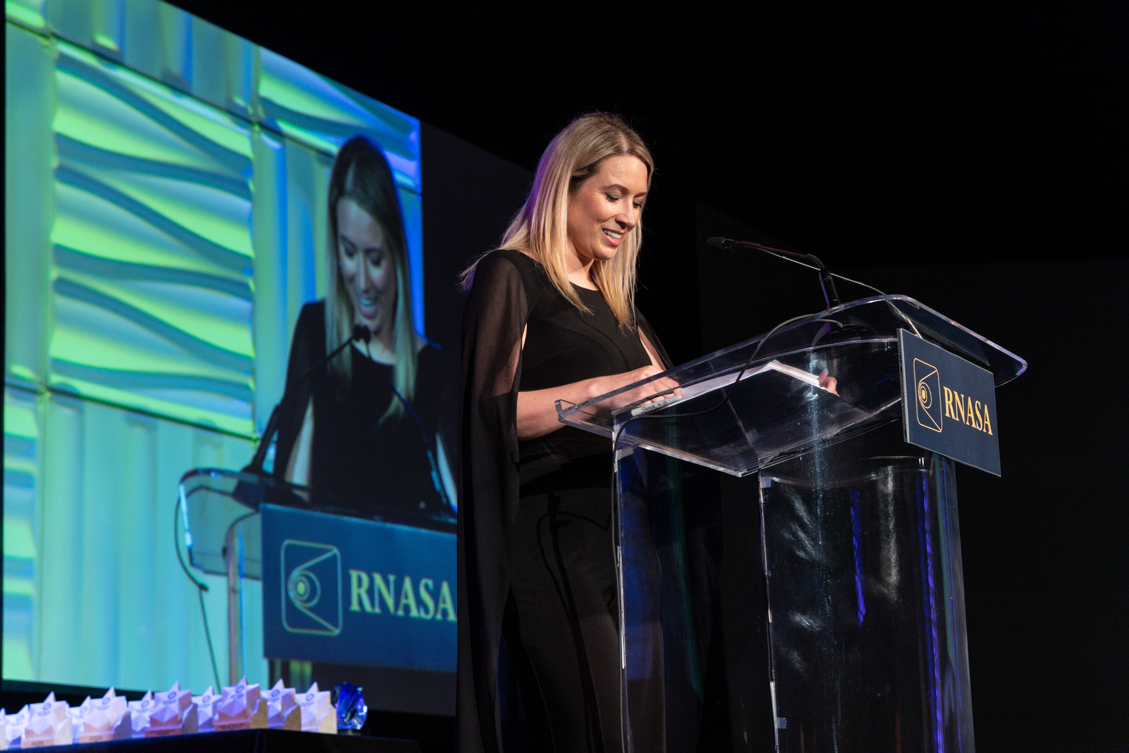
Sarah Cruddas, space journalist and international TV host served as the master of ceremonies. (RNASA photo, 2022)

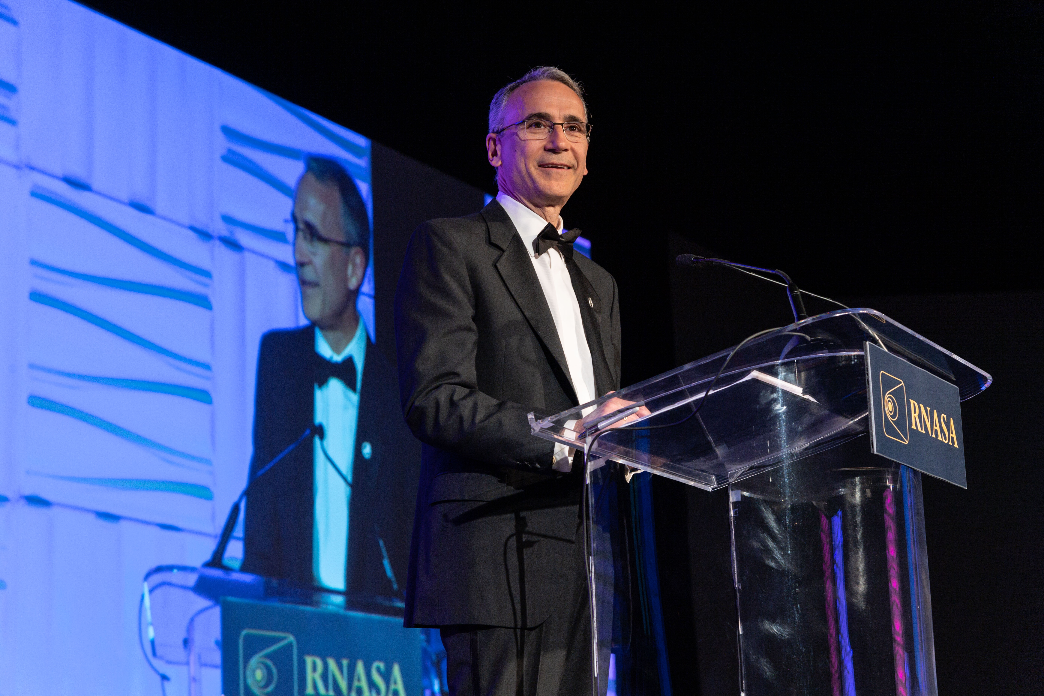
Steve Isakowitz, President and CEO of The Aerospace Corporation as the featured speaker. (RNASA photo, 2022)

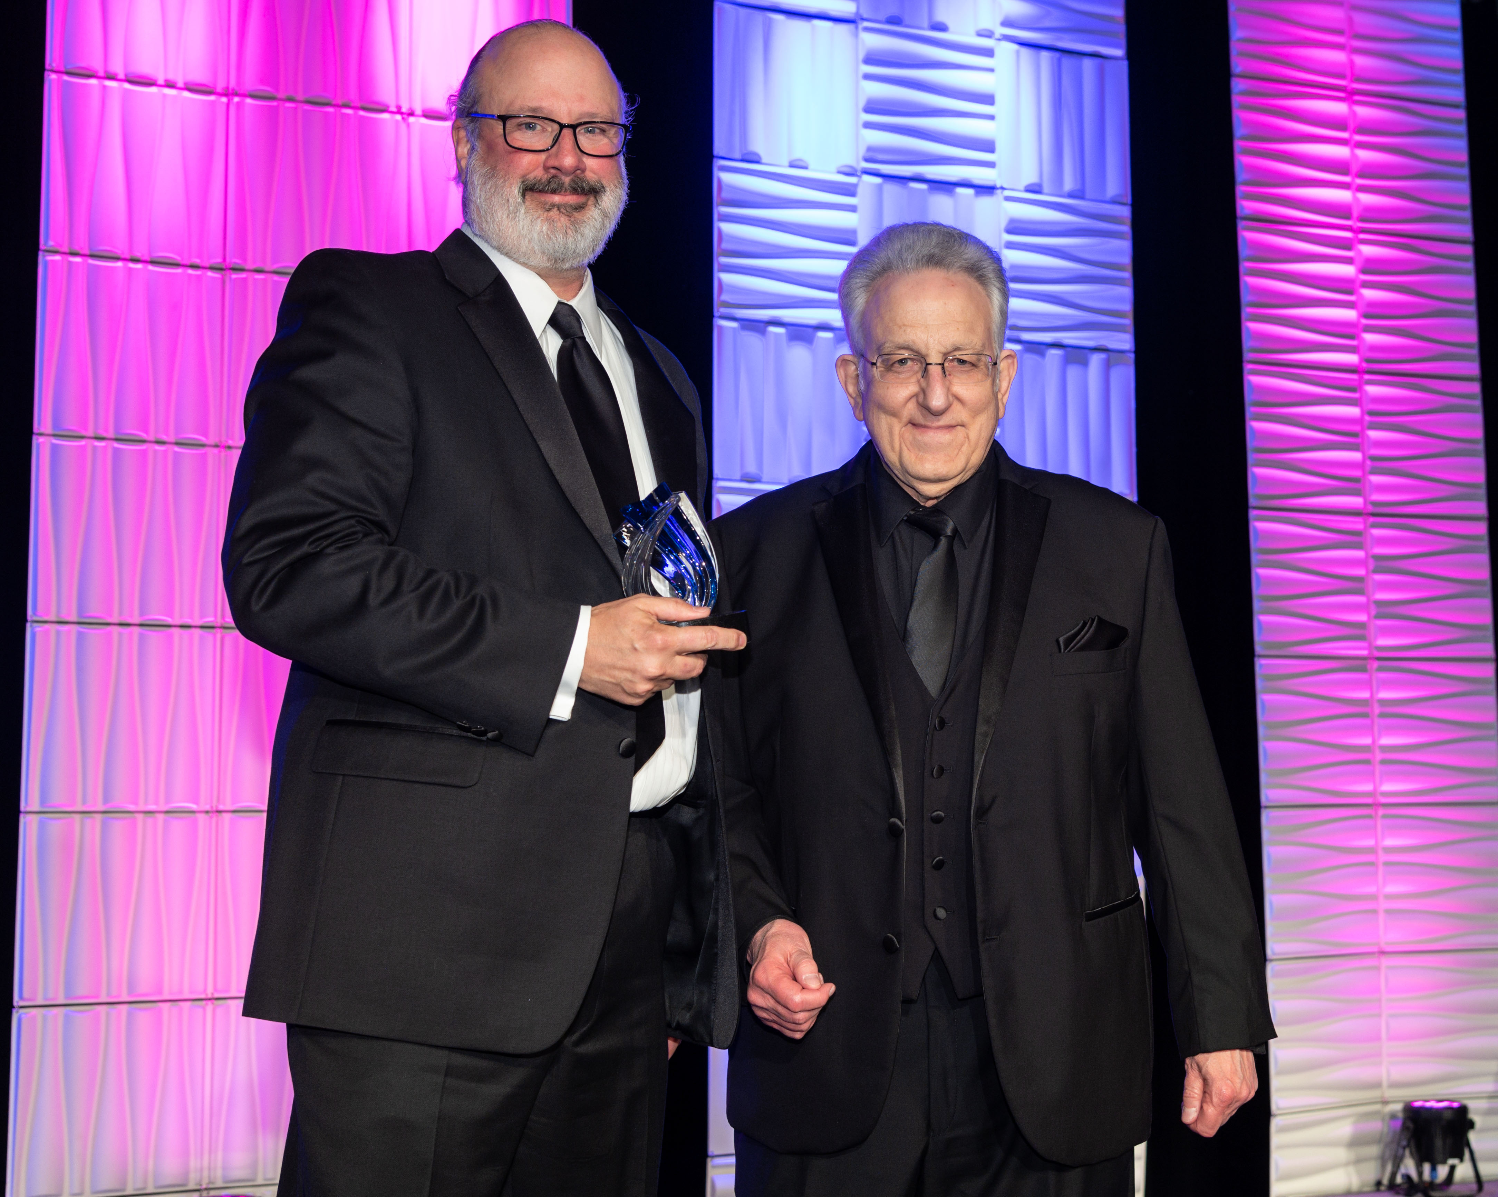
Rob Navias (right), 2017 Space Communicator winner, presents the 2020/2022 Space Communicator trophy to photographer Bill Ingalls (left) (RNASA photo, 2022)

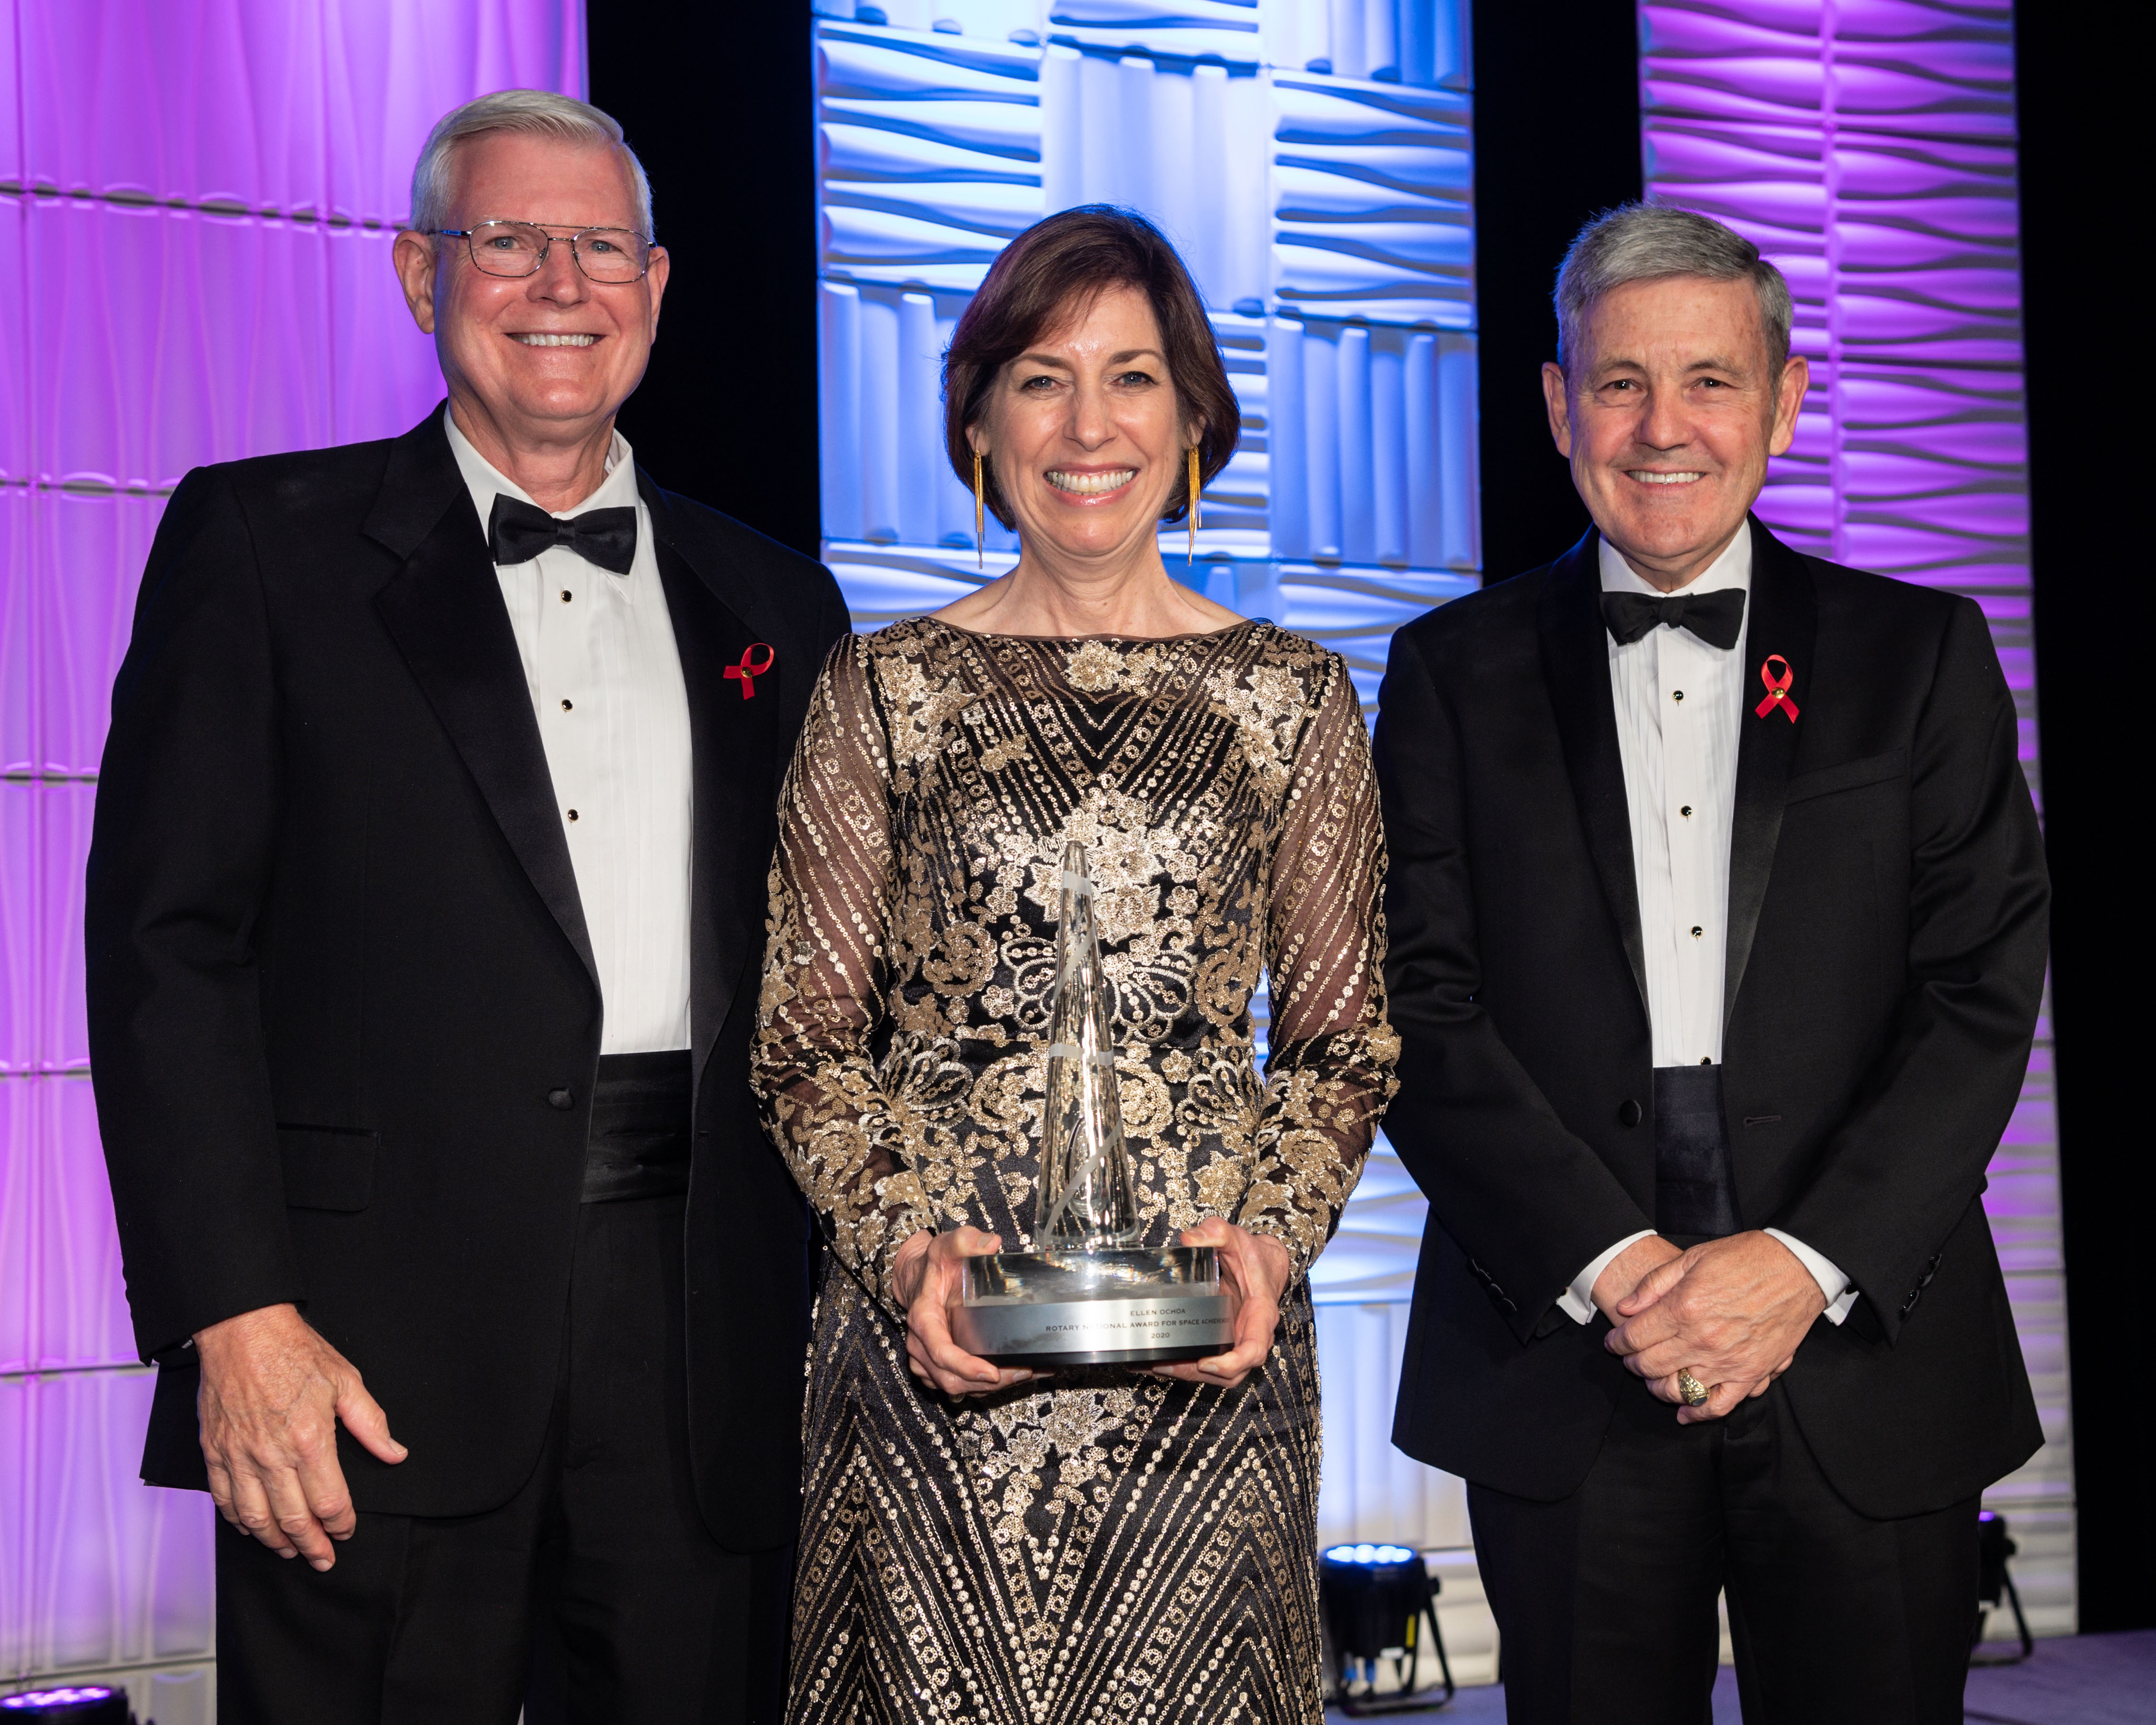

Michael Coats (left) and Robert Cabana (right) present the 2020/2022 National Space Trophy to former JSC center Director, Ellen Ochoa (center)(RNASA photo, 2022)

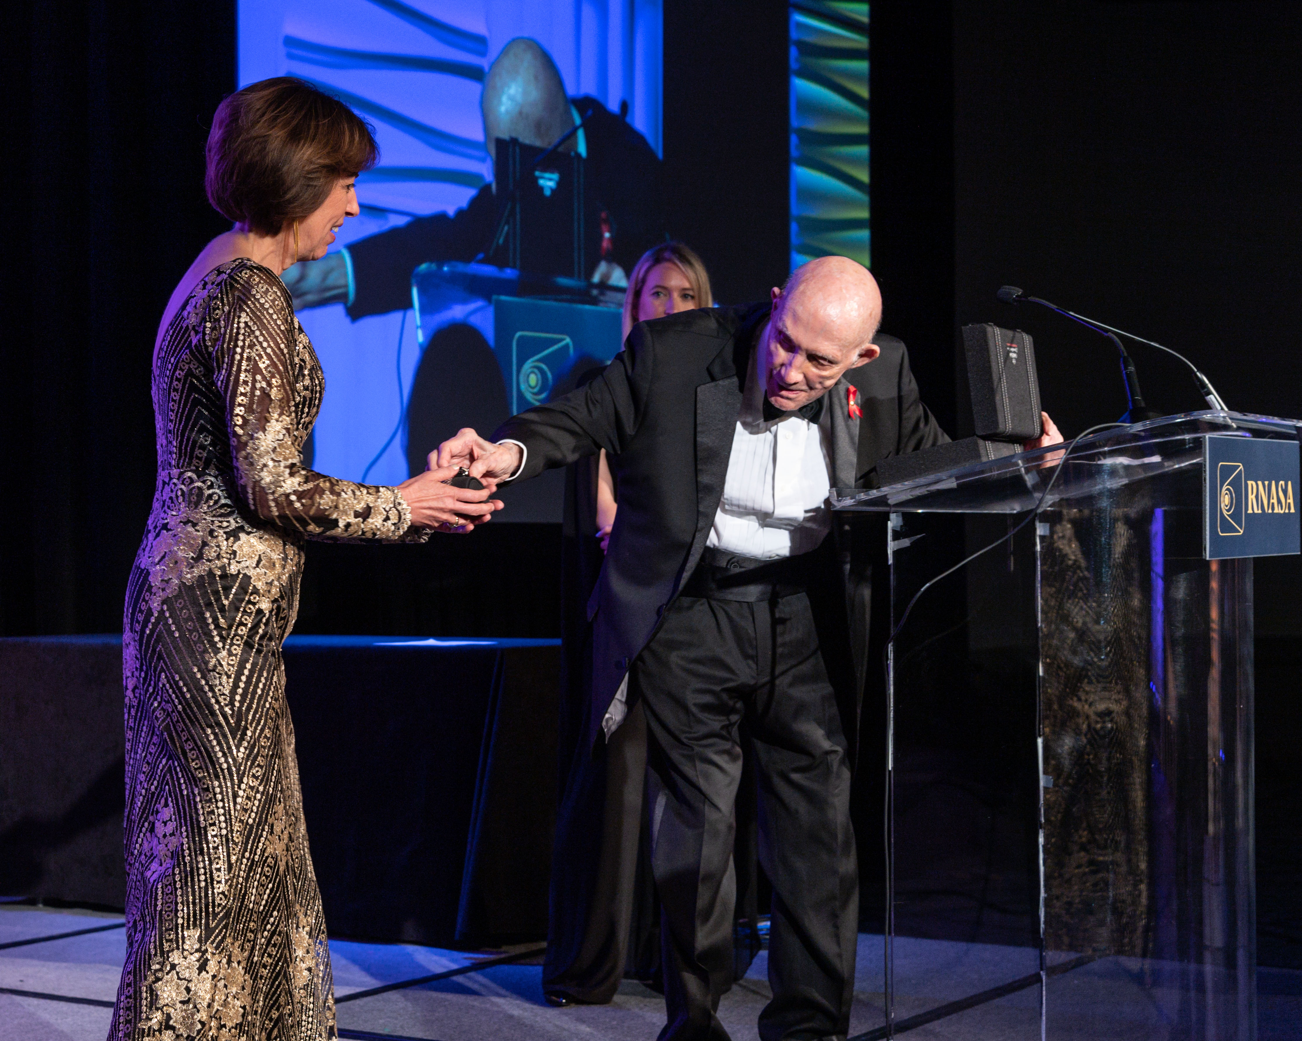
Lt. Gen. Thomas Stafford presents the OMEGA speedmaster watch to Dr. Ellen Ochoa (RNASA photo, 2022)

