PRESS RELEASE
Board of Advisors

Abbey, George W.S.
Albaugh, James F.
Aldrich, Arnold D.
Aldridge, Edward C.
Asker, Jim
Augustine, Norman R.
Barnes, Virginia A.
Brandenstein, Dan
Cabana, Robert D.
Campbell, Donald J.
Carr, Jeffrey E.
Carreau, Mark E.
Cernan, Eugene
Chilton, Kevin P.
Coats, Michael L.
Collins, Eileen M.
Covey, Richard O.
Crippen, Robert
Culbertson, Frank L.
Dickman, Robert
Dittemore, Ronald D.
Engle, Joe H.
Fuqua, Donald
Gerstenmaier, William H.
Glenn, John H.
Griffin, Gerald D.
Griffin, Michael D.
Hartsfield, Henry W.
Hartz, Jim
Heflin, J. Milt
Hendershot, Cynthia
Hieb, Richard J.
Hill, Shephard W.
Holloway, Tommy W.
Hutchinson, Neil B.
Hutchison, Kay Bailey
Johnson, Sandra G.
Karas, John C.
Kerwin, Joseph P.
Kraft, Christopher C.
Kranz, Eugene F.
Kropp, Debbie
Lunney, Glynn S.
Mitchell, Bob
Mueller, George E.
Nield, George C.
O'Brien, Miles
Parsons, William W.
Pavlovich, J. Gregory
Pickens, Thomas B.
Pulham, Elliot G.
Readdy, William F.
Reightler, Kenneth S.
Schmitt, Harrison H.
Shaw, Brewster H.
Short, W. Tom
Sirangelo, Mark N.
Stafford, Thomas P.
Staples, William A.
Stephens, Richard D.
Stone, Randy
Truly, Richard H.
Vantine, William
Whitesides, George
Young, John W.

----------------------------------------------------------------------------------------------------
For immediate release January 23, 2013
Media Contact: Lindsey Cousins, 281-480-2486, Lindsey@baysidegraphics.net
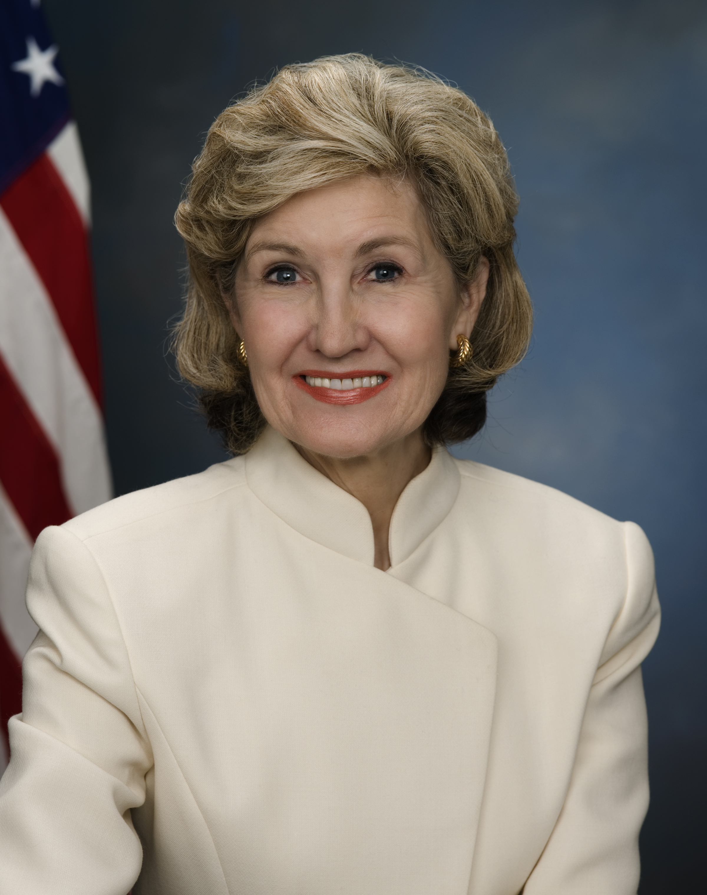

Kay Bailey Hutchison to Receive National Space Trophy

The Rotary National Award for Space Achievement (RNASA) Foundation has selected former United States Senator Kay Bailey Hutchison (R-TX) to receive the 2013 National Space Trophy.

Hutchison was nominated by Lockheed Martin Space Systems Company Executive Vice-President Joanne Maguire. In nominating her, Maguire credited Hutchison as a “long standing champion of NASA and DoD space programs” and recognized her bi-partisan leadership ensuring passage of the three-year 2010 NASA Authorization Act. Maguire went on to cite Hutchison’s dedication to education excellence, her promotion of the International Space Station Program, and her efforts to support the Orion Multi-Purpose Crew Vehicle, the Space Launch System and commercial space transportation amidst “dramatic program and policy shifts.”

“The RNASA Board of Advisors chose a very deserving candidate for recognition. We’re thrilled to be honoring Senator Hutchison this year,” Rodolfo González, President of the RNASA Foundation, said. Senator Hutchison will receive the award at a gala at the Houston Hyatt Regency on April 26, 2013.

Kay Bailey Hutchison is a former United States Senator (R-TX) who served from June 1993 through January 2013. As the first and only woman elected to the Senate from the State of Texas, she also became the first U.S. Senator from Texas to receive four million votes in a single election.

“A pioneer throughout her career, Senator Hutchison reflects the spirit of exploration and discovery that characterizes America’s space program” wrote Maguire.

Exercising strong leadership on the Senate Commerce Committee’s Science and Space Subcommittee, Hutchison worked hand-in-hand with NASA and the National Science Foundation on behalf of America’s space and science programs. In 2005, the Senator helped to draft a five-year plan outlining NASA’s exploration and research future which was signed into law by President George W. Bush. In 2010, as the senior Republican on the Senate Commerce Committee, Hutchison was instrumental in forging a NASA reauthorization bill which balanced future NASA exploration missions with commercial space investments, while authorizing funds for an additional shuttle mission.

She also led the charge to promote the International Space Station (ISS) as a National Laboratory. Her support and this designation is stimulating groundbreaking research among government agencies, universities and the private sector aboard the ISS.

Hutchison’s commitment to educational excellence has been evident through her work on programs such as the America COMPETES Act and The Academy of Medicine, Engineering, and Science of Texas (TAMEST). The America COMPETES Act, which became law in 2007, invests in the development of Science, Technology, Engineering and Mathematics (STEM) education, and prepares students for future careers in aerospace. In 2010, Hutchison went on to include a provision in the reauthorization bill that allows participating colleges and universities to certify STEM majors as elementary and secondary school teachers.

In her home state of Texas, Hutchison helped establish the Academy of Medicine, Engineering, and Science of Texas (TAMEST) to recognize the state’s top achievers in these fields. TAMEST’s success has not only brought federal investments to Texas institutions but has established the state as an important destination and center of achievement in these fields. Due to the success of this program, ten Nobel Laureates now call Texas institutions home.

Originally from La Marque, Texas, Hutchison graduated from the University of Texas at Austin with a Bachelor of Arts degree in 1962. She went on to earn a J.D. from the University of Texas Law School. Her political career began in 1972, when she served in the Texas House of Representatives until 1976. She went on to serve as vice-chairman of the National Transportation Safety Board from 1976 to 1978. She then left politics for business until 1990 when she was elected Texas State Treasurer. In 1993, Hutchison became the first woman to be elected to represent Texas in the United States Senate. She was re-elected one year later to a six-year-term and again in 2006 by an overwhelming margin. From 2001 to 2007, Hutchison served as the Senate Republican Conference Chairwoman, making her the fifth-ranking Republican in the Senate. During her time in the Senate, she served on the Appropriations, Commerce, Science and Transportation, Rules and Administration, and Veterans’ Affairs Committees. She retired from the Senate in January 2013.

Hutchison and her husband, Ray, live in Dallas with their two adopted children.

The RNASA Foundation invites members of the public and aerospace community to attend the black-tie event on April 26 at the Houston Hyatt Regency where Senator Hutchison will be recognized with the National Space Trophy. Please see http://www.rnasa.org for information about sponsorships and tickets.

About RNASA: The Rotary National Award for Space Achievement (RNASA) Foundation was founded by the Space Center Rotary Club of Houston, Texas in 1985 to organize and coordinate an annual event to recognize outstanding achievements in space and create greater public awareness of the benefits of space exploration. The nonprofit Foundation presents the National Space Trophy and Stellar Awards each year.

-END-

Page 3 of 3

