PRESS RELEASE
Board of Advisors

Abbey, George W. S.
Albaugh, Jim
Aldrich, Arnold D.
Aldridge, Jr., Edward C.
Allen, Lew
Armstrong, Neil A.
Asker, Jim
Augustine, Norman R.
Brandenstein, Dan
Cabana, Robert
Campbell, Donald J.
Carr, Jeffrey E.
Carreau, Mark E.
Cernan, Eugene
Coats, Michael L.
Cohen, Aaron
Collins, Eileen M.
Covey, Richard O.
Crippen, Robert
Culbertson, Jr., Frank L.
Dickman, Robert
Dittemore, Ronald D.
Engle, Joe H.
Estess, Roy S.
Fuqua, Donald
Gerstenmaier, William H.
Glenn, Jr., John H.
Griffin, Gerald D.
Griffin, Michael D.
Hartsfield, Henry W.
Hartz, Jim
Heflin, J. Milt
Hendershot, Cynthia
Hill, Shepard W.
Holloway, Tommy W.
Hutchinson, Neil B.
Hutchison, Kay Bailey
Johnson, Sandra G.
Karas, John C.
Kerwin, Joseph P.
Kraft, Jr., Christopher C.
Kranz, Eugene F.
Kropp, Debbie
Lunney, Glynn S.
McCall, Robert T.
Mitchell, Bob
Mueller, George E.
O’Brien, Miles
Parsons, William W.
Pickens, III, Thomas B.
Pulham, Elliot G.
Readdy, William F.
Reightler, Kenneth S.
Schmitt, Harrison H.
Shaw, Brewster H.
Short, Tom W.
Stafford, Thomas P.
Staples, William A.
Stephens, Richard D.
Stone, Randy
Truly, Richard H.
Vantine, William
Wilkins, III, John S.
Young, John W.

----------------------------------------------------------------------------------------------------
For immediate release March 23, 2011
Media Contact: Marianne Dyson, 281-486-4747, dyson@rnasa.org

Rotary National Award for Space Achievement Plans 25th Anniversary Gala

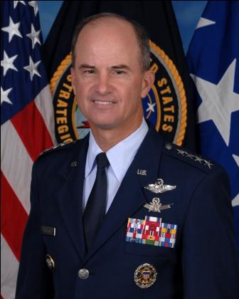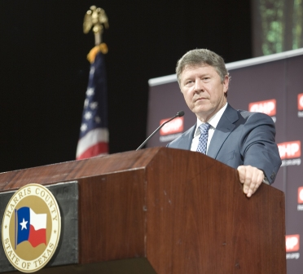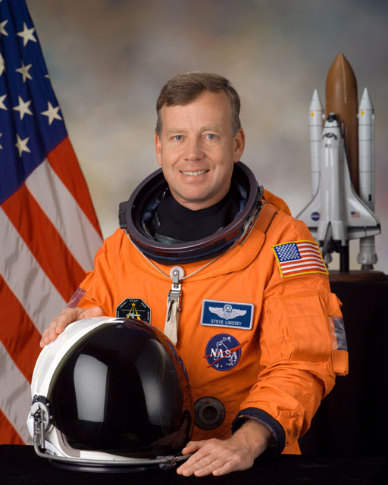
(Chilton, USAF Photo; Emmett, Dabfoto Creative/David A. Brown; Lindsey, NASA Photo)

The Rotary National Award for Space Achievement (RNASA) Foundation is proud to be celebrating its silver anniversary with a gala event on May 6, 2011 at the Houston Hyatt Regency hotel. Founded by the Space Center Rotary Club in 1985 to organize and coordinate an annual event to recognize outstanding achievements in space and create greater public awareness of the benefits of space exploration, the Foundation has presented the National Space Trophy to an outstanding American who has made major contributions to our nation's space program since 1987.

The RNASA Board of Advisors selected recently retired Commander of U.S. Strategic Command, and former Space Shuttle Astronaut, General Kevin P. Chilton, USAF (Ret.) as the 25th recipient of the National Space Trophy.

“General Chilton, as an Air Force commander and a former astronaut, is being recognized for his leadership in both our civilian and military space programs,” Rodolfo González, President of the RNASA Foundation, said.

The Trophy will be presented to General Chilton by Astronaut Steven W. Lindsey, Colonel, USAF (Ret.) who commanded the last flight of the Space Shuttle Discovery that landed on March 9.

Harris County Judge Ed Emmett will welcome guests to the event; the Clear Creek High School JROTC Color Guard will present the colors, and veteran reporter Miles O’Brien will serve as emcee. Former Apollo Astronaut Lt. Gen. Thomas Stafford, USAF (Ret.) will present an Omega watch to Gen. Chilton.
Continued
Record Number of RNASA Stellar Award Nominees

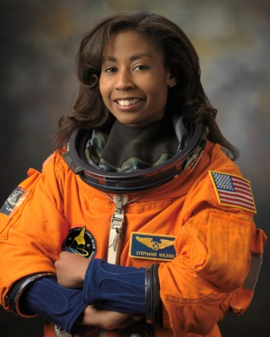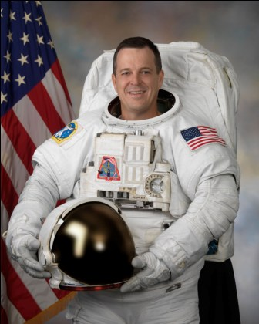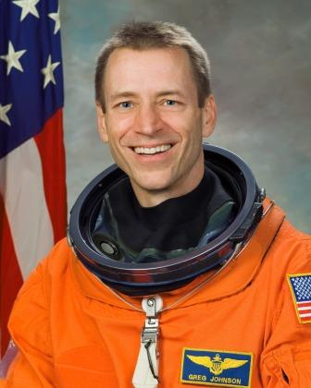
(Wilson, Arnold, Johnson, NASA Photos)

The winners of the annual RNASA Stellar Awards will be announced at the National Space Trophy gala in the evening of May 6 at the Houston Hyatt Regency. Veteran NASA Astronauts Stephanie D. Wilson and Richard R. Arnold, II will announce the winners and present them with engraved marble trophies.

“We had a record number of 151 Stellar Award nominees this year,” reported Jennifer Mitchell, the RNASA Stellar Awards Committee Chairman. The nominations are subdivided into four categories, and the Foundation received 29 early career, 51 middle career, 35 late career, and 36 team nominations. NASA nominated 19 individuals and seven teams, the USAF nominated five individuals and four teams, and industry nominated 91 individuals and 25 teams.

Winners are selected by a Stellar Awards Evaluation Panel based on which accomplishments hold the greatest promise for furthering future activities in space, the extent to which the nominee played a key role in the accomplishment, and the extent to which the nominee meets the goal of recognizing "unsung heroes." The 2011 Evaluation Panel consists of former National Space Trophy winners, Dr. Christopher C. Kraft Jr. and Dr. Glynn S. Lunney, and former National Associate Administrator for Space Systems Development, Arnold D. Aldrich.

Prior to the evening banquet, the Stellar Award nominees and their spouse or guest will enjoy a behind-the-scenes tour of Johnson Space Center and a special Stellar Awards Luncheon at the Nassau Bay Hilton. Hubble Servicing Mission (STS-125) Pilot, Captain Gregory C. Johnson, UNS (Ret.) is the featured luncheon speaker.

Each nominee will receive a special commemorative certificate at the luncheon and a special ribbon to identify them at the evening’s banquet event.

The banquet is open to the public, but seating is limited. Please visit http://www.rnasa.org/tables.html for ticket information or contact Bill Taylor at 281-488-2733 prior to April 8, 2011.The RNASA Foundation is supported by corporate sponsorships. Proceeds remaining after each year's event are donated to an organization involved in aerospace education.
-END-

