PRESS RELEASE
Board of Advisors

Abbey, George W. S.
Albaugh, Jim
Aldrich, Arnold D.
Aldridge, Jr., Edward C.
Armstrong, Neil A.
Asker, Jim
Augustine, Norman R.
Brandenstein, Dan
Cabana, Robert
Campbell, Donald J.
Carr, Jeffrey E.
Carreau, Mark E.
Cernan, Eugene
Coats, Michael L.
Collins, Eileen M.
Covey, Richard O.
Crippen, Robert
Culbertson, Jr., Frank L.
Dickman, Robert
Dittemore, Ronald D.
Engle, Joe H.
Fuqua, Donald
Gerstenmaier, William H.
Glenn, Jr., John H.
Griffin, Gerald D.
Griffin, Michael D.
Hartsfield, Henry W.
Hartz, Jim
Heflin, J. Milt
Hendershot, Cynthia
Hill, Shepard W.
Holloway, Tommy W.
Hutchinson, Neil B.
Hutchison, Kay Bailey
Johnson, Sandra G.
Karas, John C.
Kerwin, Joseph P.
Kraft, Jr., Christopher C.
Kranz, Eugene F.
Kropp, Debbie
Lunney, Glynn S.
Mitchell, Bob
Mueller, George E.
O’Brien, Miles
Parsons, William W.
Pickens, III, Thomas B.
Pulham, Elliot G.
Readdy, William F.
Reightler, Kenneth S.
Schmitt, Harrison H.
Shaw, Brewster H.
Short, Tom W.
Stafford, Thomas P.
Staples, William A.
Stephens, Richard D.
Stone, Randy
Truly, Richard H.
Vantine, William
Wilkins, III, John S.
Young, John W.

---------------------------------------------------------------------------------------------------------
For immediate release Sept. 1, 2010
Media Contact: Marianne Dyson, 281-486-4747, dyson@rnasa.org

RNASA Foundation Donates Proceeds to Support Students

The Rotary National Award for Space Achievement (RNASA) Foundation is pleased to announce donations totaling $34,000 for the purpose of inspiring youth to study science, technology and engineering.

This amount includes $20,000 from the Foundation, and $7,000, in honor of the 2010 National Space Trophy winner, Bill Gerstenmaier, donated to the Texas High School Aerospace Scholars (HAS) program. Another $7,000 is being donated in honor of the 2009 National Space Trophy winner, Michael Griffin, to the U.S. Space and Rocket Center Foundation to support Space Camp.

“The Foundation has been fortunate to have such strong support from the aerospace community in the past few years that we’ve been able to cover the expenses of our events and have funds remaining to support space-related educational programs,” RNASA Foundation President Rodolfo González said.

The RNASA Foundation’s 25th anniversary gala event will be held at the Houston Hyatt Regency on May 6, 2011. For information on RNASA and sponsorship opportunities, please visit www.rnasa.org.

"This is a tremendous gift," according to Larry Capps, the CEO of the U.S. Space & Rocket Center in Huntsville, Alabama, home of Space Camp. He added, "We've been working to get youngsters excited about math and science for the last 28 years. This gift will make it possible for even more students to take advantage of our scholarship program."

The RNASA Foundation donations to the Texas HAS program will allow more students to complete on-line lessons and then spend a week during the summer at Johnson Space Center where they are briefed by engineers, scientists, and astronauts; and work in teams to cooperatively design a human mission to Mars. From the program’s beginning in 1999 to 2010, about 7,000 students have participated in the program. Students are nominated to participate by their Texas state legislator through a competitive process. TAS Program Manager, Jessica Cejka, said the program is being expanded to other states and will include special all-girl sessions next year. Visit http://aerospacescholars.jsc.nasa.gov for more information.

Houston area high school student Nancy Shenoi who addressed the luncheon crowd of students, parents, instructors, and mentors on July 16, said the

continued
experience, “Profoundly affected my life.” Astronaut Mike Fossum and National Space Trophy winner and former Apollo Flight Director Glynn Lunney were among the space program veterans that she heard from during her week at Johnson Space Center. She said as a result of this program, she will “actively seek a career in science, maybe as a flight doctor.”

Past recipients of RNASA donations include Purdue, the University of Houston-Clear Lake, the Wings of the Eagle Foundation, Parks College of Engineering at St. Louis University, Space Center Houston, and the National Flight Academy adjacent to the National Museum of Naval Aviation in Pensacola, FL.

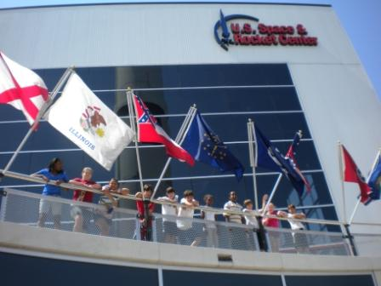
The RNASA donation in honor of former NASA Administrator and 2009 National Space Trophy winner Michael Griffin to the U.S. Space & Rocket Center will allow more students ages 9 to 11 to attend Space Camp. (Photo courtesy USSRC, April 2010)

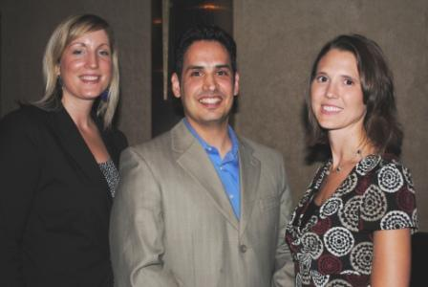
High School Aerospace Scholars Manager Nora Ojo, RNASA Foundation President Rodolfo González, and Texas Aerospace Scholars Program Manager Jessica Cejka pose for a photo at an RNASA Appreciation dinner August 19, 2010. (Photo by Mary Alys Cherry, The Citizen)

continued

2 of 3

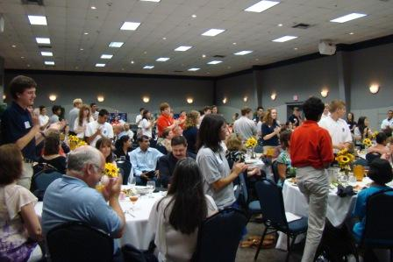
Texas High School Aerospace Scholars Week 4 students applaud the supporters who made their week-long experience at Johnson Space Center possible. The RNASA Foundation provided a $20,000 donation in 2010. (Photo by Marianne Dyson, July 16, 2010)

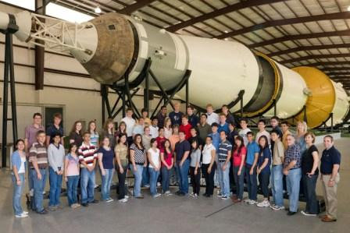
Texas High School Aerospace Scholars Week 4 students pose in front of the Saturn V at Johnson Space Center. The 8-week program served 367 students from high schools all around Texas. (Photo by Lauren Harnett, July 13, 2010)

High resolution versions of the above images are available for download at http://www.rnasa.org/photos.html.

END

3 of 3

