Board of Advisors

Abbey, George W.S.
Albaugh, James F.
Aldrich, Arnold D.
Aldridge, Edward C.
Augustine, Norman R.
Bolden, Charles F.
Brandenstein, Dan
Cabana, Robert D.
Callahan, Lisa
Campbell, Donald J.
Carr, Jeffrey E.
Carreau, Mark E.
Cazes, David
Chilton, Kevin P.
Coats, Michael L.
Collins, Eileen M.
Covey, Richard O.
Crippen, Robert
Culbertson, Frank L.
Dittemore, Ronald D.
Elachi, Charles
Elbon, John W.
Engle, Joe H.
Flynt, G. Allen
Free, James M.
Fuqua, Donald
Gerstenmaier, William H.
Geyer, Mark
Griffin, Gerald D.
Griffin, Michael D.
Grunsfeld, John M.
Hartz, Jim
Heflin, J. Milt
Hendershot, Cynthia
Hernandez, Jorge
Hieb, Richard J.
Holloway, Tommy W.
Hutchinson, Neil B.
Hutchison, Kay Bailey
Johnson, Sandra G.
Karas, John C.
Kavandi, Janet L.
Kerwin, Joseph P.
Kranz, Eugene F.
Kropp, Debbie
Lightfoot, Robert
Lunney, Glynn S.
Magnus, Sandra H.
May, Todd A.
McBride, David D.
McDonald, Vernon
Meyerson, Robert E.
Miller, Lon
Mitchell, Bob
Mulqueen, Mark E.
Nield, George C.
O'Brien, Miles
Ochoa, Ellen
Parsons, William W.
Pavlovich, J. Gregory
Pickens, Thomas B.
Readdy, William F.
Reightler, Kenneth S.
Schmitt, Harrison H.
Scolese, Christopher J.
Shaw, Brewster H.
Sirangelo, Mark N.
Stafford, Thomas P.
Staples, William A.
Stegemoeller, Charles M.
Stephens, Richard D.
Suffredini, Michael
Swallow, Edward M.
Thompson, David W.
Truly, Richard H.
Vantine, William
Wagner, Elizabeth
Whitesides, George
For Immediate Release
February 4, 2020
Media Contact: Lindsey Cousins
281-723-5683, lindsey@baysidegraphics.net

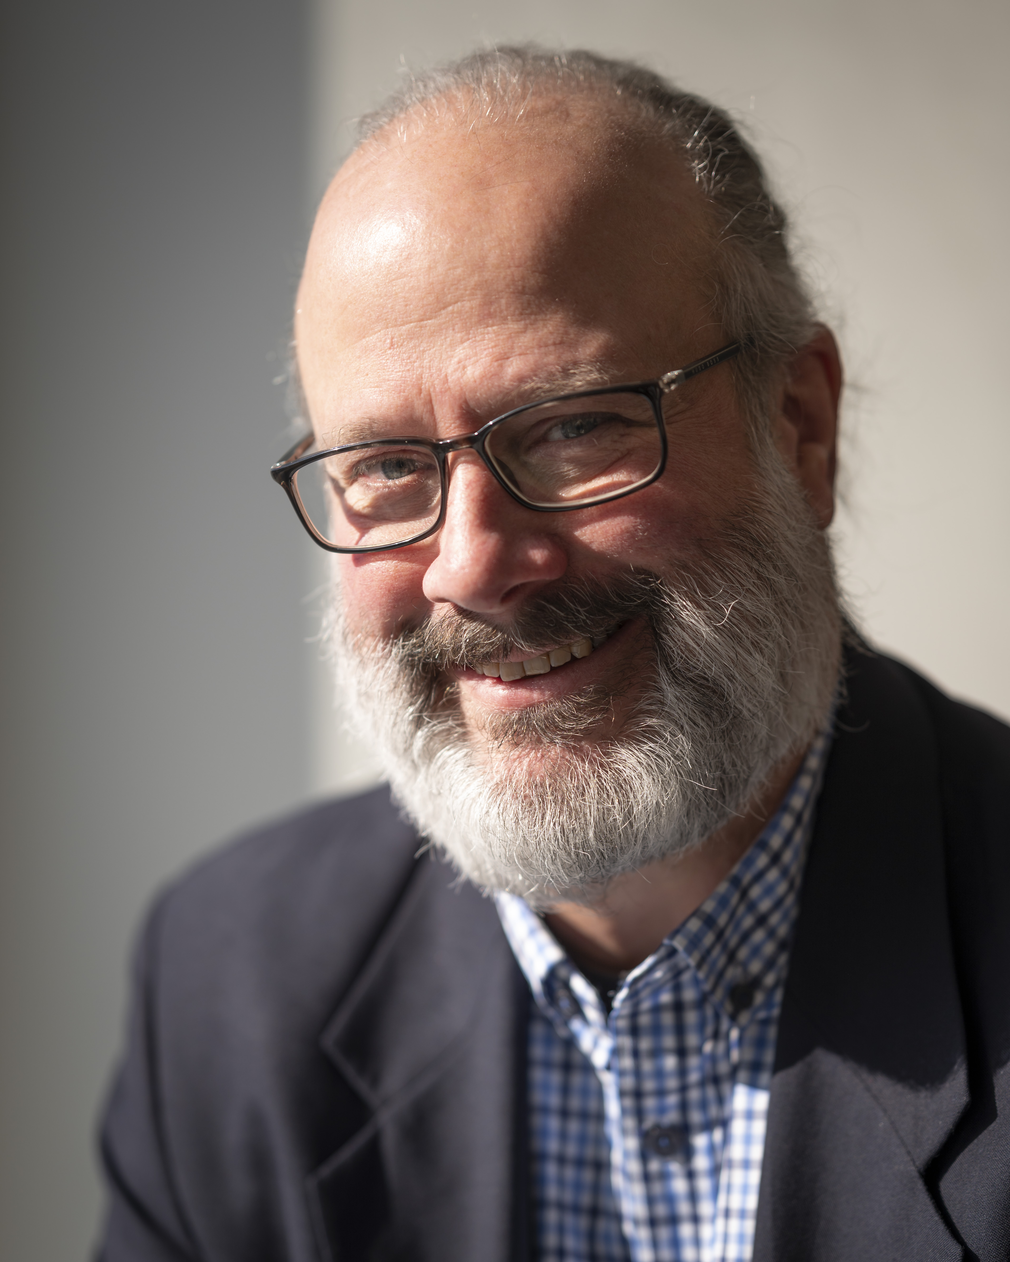Photo Credit: NASA/Joel Kowsky

Bill Ingalls, NASA Senior Photographer, to receive RNASA’s 2020 Space Communicator Award

HOUSTON, Texas (February 4, 2020). The Rotary National Award for Space Achievement (RNASA) Foundation has selected Bill Ingalls, NASA Senior Photographer, to receive the prestigious 2020 Space Communicator Award.

For over three decades Bill Ingalls has been capturing NASA’s most spectacular moments through his camera lens. His career was born in 1987 when he landed an internship at NASA’s communications office. After graduating from the Waynesburg College with two Bachelor of Art degrees in English and Visual Communications, Ingalls returned to NASA where he joined a group of accomplished and esteemed photographers in 1989.

Bill has crisscrossed the globe photographing some of our country’s most historic and compelling images. His iconic photos have captured Neil Armstrong’s burial at sea, Space Shuttle Endeavor’s final landing in 2011, and the first launch of a US citizen on a Russian rocket. As one of NASA’s most senior photographers, Bill manages over 400 projects annually and supervises a team of five.

Ingalls said of his award, “I am incredibly honored, not only to have been selected to receive this recognition, but to be given the trust and responsibility to document space history in order to share NASA’s story for this and future generations.”

His assignments have taken him to some of the most extreme environments imaginable. He has been lowered into an active volcano in Alaska, endured -17° temperatures for a Soyuz landing in the Kazakh steppes, and flown through a hurricane aboard a DC-8.

Bob Jacobs, NASA Deputy Associate Administrator for Communications, who nominated Ingalls said, “Bill is so much more than a photographer, he’s a storyteller,” said Bob Jacobs, NASA’s deputy associate administrator for the Office of Communications who nominated Ingalls. “Bill takes us on this amazing journey of spaceflight through this camera lens, whether it’s the beauty and power of a launch or the exhaustion and excitement of an astronaut’s return home. He’s able to turn the vastness of space into very intimate moments. It’s a special talent.”

Bill is the second photographer to ever be honored with the National Space Club Press Award. Legendary journalist Edward R. Murrow was the first. Bill’s work has been highlighted in National Geographic, Newsweek, TIME, The Washington Post, Fortune, People, The New York Times, and the Los Angeles Times and has been featured on NBC, CBS and ABC News. To view more of his work please visit Bill’s website at ingallsimages.com.

The RNASA Space Communicator Award was created in 1997 in honor of KTRK, Houston Channel 13 space reporter and long-time RNASA Advisor Stephen Gauvain who was tragically killed in a car accident in 1996. The award is presented to an individual or team that makes exceptional contributions to public understanding and appreciation of space exploration The previous recipients of the award are: William Shatner; William Harwood of CBS; Miles O'Brien, formerly of CNN; Elliot Pulham of the Space Foundation; the NASA-Contractor Communications team that responded to the Columbia accident; Mark Carreau, formerly of the Houston Chronicle; Neil deGrasse Tyson of the Hayden Planetarium at the American Museum of Natural History in New York City, Veronica McGregor, Manager of News and Social Media at NASA's Jet Propulsion Laboratory in Pasadena, California; former Canadian Space Agency astronaut, author, and musician Chris A. Hadfield; Bill Nye (the science guy) CEO of the Planetary Society, and Rob Navias of NASA’s Johnson Space Center.

Ingalls will be honored with the 2020 Space Communicator Award at RNASA’s 34th annual National Space Trophy Banquet on April 17, 2020, at the Houston Hyatt Regency. Dr. Ellen Ochoa, Retired Johnson Space Center Director, will receive the 2020 National Space Trophy.

The RNASA Foundation invites members of the public and the aerospace community to attend the black-tie event on April 17, 2020, at the Houston Hyatt Regency. Please visit http://www.rnasa.org/tables.html to reserve your table for the RNASA Banquet and find information about sponsorships and tickets. To reserve a room at the Houston Hyatt Regency, please visit http://www.rnasa.org/houston.html or call 713-654-1234 and request the RNASA group rate. The RNASA website is http://www.rnasa.org/.

About RNASA: The Rotary National Award for Space Achievement (RNASA) Foundation was founded by the Space Center Rotary Club of Houston, Texas in 1985 to organize and coordinate an annual event to recognize outstanding achievements in space and create greater public awareness of the benefits of space exploration. The nonprofit Foundation presents the National Space Trophy and Stellar Awards each year.

