Board of Advisors

Abbey, George W.S.
Albaugh, James F.
Aldrich, Arnold D.
Aldridge, Edward C.
Augustine, Norman R.
Bolden, Charles F.
Bowles, David E.
Brandenstein, Dan
Cabana, Robert D.
Callahan, Lisa
Campbell, Donald J.
Carr, Jeffrey E.
Carreau, Mark E.
Cazes, David
Chilton, Kevin P.
Coats, Michael L.
Collins, Eileen M.
Covey, Richard O.
Crippen, Robert
Culbertson, Frank L.
Dittemore, Ronald D.
Elachi, Charles
Elbon, John W.
Engle, Joe H.
Flynt, G. Allen
Free, James M.
Fuqua, Donald
Gerstenmaier, William H.
Geyer, Mark
Griffin, Gerald D.
Griffin, Michael D.
Grunsfeld, John M.
Hartz, Jim
Heflin, J. Milt
Hendershot, Cynthia
Hernandez, Jorge
Hieb, Richard J.
Holloway, Tommy W.
Hutchinson, Neil B.
Hutchison, Kay Bailey
Johnson, Sandra G.
Karas, John C.
Kavandi, Janet L.
Kerwin, Joseph P.
Kranz, Eugene F.
Kropp, Debbie
Lightfoot, Robert
Lunney, Glynn S.
Magnus, Sandra H.
May, Todd A.
McBride, David D.
McDonald, Vernon
Meyerson, Robert E.
Miller, Lon
Mitchell, Bob
Mulqueen, Mark E.
Nield, George C.
O'Brien, Miles
Ochoa, Ellen
Parsons, William W.
Pavlovich, J. Gregory
Pickens, Thomas B.
Readdy, William F.
Reightler, Kenneth S.
Schmitt, Harrison H.
Scolese, Christopher J.
Shaw, Brewster H.
Sirangelo, Mark N.
Stafford, Thomas P.
Staples, William A.
Stegemoeller, Charles M.
Stephens, Richard D.
Suffredini, Michael
Swallow, Edward M.
Truly, Richard H.
Vantine, William
Wagner, Elizabeth
Whitesides, George
For Immediate Release January 10, 2019
Media Contact: Lindsey Cousins
281-723-5683, lindsey@baysidegraphics.net

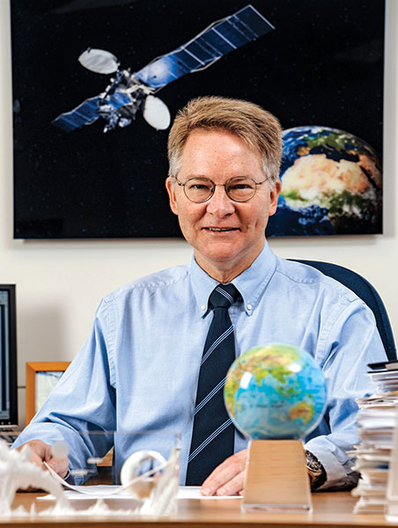

Mr. David W. Thompson, Retired President and CEO of Orbital ATK, to receive the 2019 National Space Trophy

Bay Area, Houston, Texas (January 10, 2019). The Rotary National Award for Space Achievement (RNASA) Foundation has selected Mr. David W. Thompson, Retired President and CEO of Orbital ATK, to receive the 2019 National Space Trophy. The banquet honoring Mr. Thompson will be held on April 26, 2019, at the Houston Hyatt Regency in Houston, Texas.

Rodolfo Gonzalez, President of the RNASA Foundation said, "The RNASA Foundation is extremely excited about recognizing Mr. Thompson as the guest of honor at the 2019 RNASA Space Award Gala.”

Mr. Thompson was nominated for the award by Captain Frank Culbertson (U.S. Navy, ret.), of Northrop Grumman Corporation. In recommending Thompson, Culbertson cited his “four decades of outstanding leadership and pioneering innovations in the development and operation of launch vehicles and satellite systems, which have transformed scientific, exploratory, commercial and defense applications of space."

Thompson said, “It is with great enthusiasm, and even greater humility, that I accept the 2019 National Space Trophy! My heart-felt thanks to the RNASA Board of Advisors for selecting me for this highly-regarded honor.”

Thompson began his four-decade long career in space technology as a young engineer at NASA’s Marshall Space Flight Center in 1978, following summer internships during college and graduate school at the Jet Propulsion Laboratory, Johnson Space Center and Langley Research Center. His career as a space entrepreneur and business leader accelerated in the early 1980’s when he and two Harvard Business School classmates founded Orbital Sciences Corp., a startup that focused on the development of space systems for commercial, military and scientific customers. Over the subsequent 35 years, Thompson led his company from its infancy to Fortune 500 status, reaching more than $5 billion in annual revenue and employing nearly 15,000 people in 2018.

As one of the world’s first commercial space enterprises, Orbital pioneered the investment of private capital for space systems development and manufacturing in the 1980’s and 1990’s. During this time, the company created a family of six new launch vehicles, including the Pegasus rocket and several missile defense vehicles, as well as an array of lower-cost satellites for both low-Earth orbit (LEO) and geosynchronous (GEO) applications. Thompson’s vision was that diverse customers – from traditional government agencies to new privately-owned satellite operators – would use these products, and that commercial-style business practices would reduce their costs and delivery times. The success of this strategy is reflected in the more than 1,000 rockets and satellites delivered by the company to over 50 customers since the 1980’s.

Under Thompson’s leadership, Orbital expanded beyond its original business of research and manufacturing into providing space-based services in the 1990’s and 2000’s. New ventures in those decades included its ORBCOMM satellite data and messaging system, the first global network based on dozens of small LEO satellites, and its ORBIMAGE commercial satellite imaging fleet, which pioneered privately-owned remote sensing spacecraft. More recently, the company partnered with NASA to develop the Antares rocket and Cygnus spacecraft commercial cargo system for the International Space Station (ISS), which has conducted 12 supply missions to ISS over the past six years. And later this year the company plans to inaugurate the world’s first in-space robotic servicing and repair of GEO communications satellites, launching an exciting new form of commercial space logistics operations.

In 2014, Orbital and its long-standing industry partner, Alliant Techsystems, merged to form Orbital ATK, a larger, more diversified space and defense systems company with a broader product line, including rocket propulsion for NASA’s Space Launch System (SLS) heavy-lift vehicle as well as motors for tactical and strategic missiles. Finally, last year Northrop Grumman purchased Orbital ATK for over $9 billion, forming Northrop’s Innovation Systems business sector. The merger with Northrop is expected to generate faster growth and new products, as well as creating greater opportunities for thousands of the company’s space engineers and scientists.

Thompson earned his B.S. in Aeronautics and Astronautics from Massachusetts Institute of Technology, a M.S. in Aeronautics from Caltech, and an MBA from Harvard Business School.
He is an Honorary Fellow of the American Institute of Aeronautics and Astronautics (AIAA),
a Fellow of the American Astronautical Society and the Royal Aeronautical Society, and a member of the U.S. National Academy of Engineering and the International Academy of Astronautics. He was AIAA’s President for the 2009-2010 year, and today serves as a member of the Boards of Trustees of Caltech, the Aerospace Corporation, the Carnegie Institution for Science, the Hertz Foundation, and the Princeton University Astronomy Council. He was recently appointed to the National Space Council Users’ Advisory Group and has been honored with numerous awards including the National Medal of Technology by President George H.W. Bush as well as Virginia’s Industrialist of the Year and High-Technology Entrepreneur of the Year by Inc. Magazine.

The RNASA Foundation invites members of the public and the aerospace community to attend the black-tie event on April 26, 2019, at the Houston Hyatt Regency, where Mr. Thompson will be recognized with the National Space Trophy. This year will be RNASA’s 33rd annual Space Awards Gala. Please visit http://www.rnasa.org/tables.html to reserve your table for the RNASA Banquet and find information about sponsorships and tickets. To reserve a room at the Houston Hyatt Regency, please visit http://www.rnasa.org/houston.html or call 713-654-1234 and request the RNASA group rate.

About RNASA: The Rotary National Award for Space Achievement (RNASA) Foundation was founded by the Space Center Rotary Club of Houston, Texas, in 1985 to organize and coordinate an annual event to recognize outstanding achievements in space and create greater public awareness of the benefits of space exploration. The nonprofit Foundation presents the National Space Trophy and Stellar Awards each year. The RNASA website is http://www.rnasa.org/.

