PRESS RELEASE--UPDATED
Board of Advisors

Abbey, George W. S.
Albaugh, Jim
Aldrich, Arnold D.
Aldridge, Jr., Edward C.
Allen, Lew
Armstrong, Neil A.
Asker, Jim
Augustine, Norman R.
Brandenstein, Dan
Cabana, Robert
Campbell, Donald J.
Carr, Jeffrey E.
Carreau, Mark E.
Cernan, Eugene
Coats, Michael L.
Cohen, Aaron
Collins, Eileen M.
Covey, Richard O.
Crippen, Robert
Culbertson, Jr., Frank L.
Dickman, Robert
Dittemore, Ronald D.
Engle, Joe H.
Estess, Roy S.
Fuqua, Donald
Gerstenmaier, William H.
Glenn, Jr., John H.
Griffin, Gerald D.
Hartsfield, Henry W.
Hartz, Jim
Heflin, J. Milt
Hendershot, Cynthia
Hill, Shepard W.
Holloway, Tommy W.
Hutchinson, Neil B.
Hutchison, Kay Bailey
Johnson, Sandra G.
Karas, John C.
Kerwin, Joseph P.
Kraft, Jr., Christopher C.
Kranz, Eugene F.
Kropp, Debbie
Lunney, Glynn S.
McCall, Robert T.
Mitchell, Bob
Mueller, George E.
O’Brien, Miles
Parsons, William W.
Pickens, III, Thomas B.
Pulham, Elliot G.
Readdy, William F.
Reightler, Kenneth S.
Schmitt, Harrison H.
Shaw, Brewster H.
Short, Tom W.
Stafford, Thomas P.
Staples, William A.
Stephens, Richard D.
Stone, Randy
Truly, Richard H.
Vantine, William
Wilkins, III, John S.
Young, John W.
----------------------------------------------------------------------------------------------------
For immediate release May 13, 2009
Media Contact: Marianne Dyson, 281-486-4747, dyson@rnasa.org

Mike Griffin Receives 2009 Rotary National Space Trophy

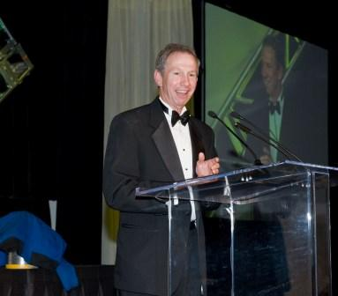The Rotary National Award for Space Achievement (RNASA) Foundation’s National Space Trophy was presented to former NASA Administrator Michael D. Griffin on Friday, May 8 at a gala held at the Houston Hyatt Regency hotel.

Guests, including former trophy winners, NASA officials, members of the military, aerospace executives, and Stellar Award nominees, were welcomed by RNASA President Rodolfo González and Harris County Judge Ed Emmett. Congressman Pete Olson presented a proclamation congratulating RNASA on 23 years of recognizing space achievement. Clear Lake High School Army JROTC presented the colors, Kemah City Councilwoman Kelly Williams sang the anthem, and Greg Finke, senior pastor of Gloria Dei Lutheran Church in Houston, gave the invocation prior to a dinner featuring filet mignon with port wine reduction and jumbo crabmeat purse.

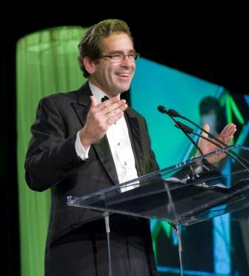Veteran space correspondent Miles O’Brien served as emcee of the event and Space City Films wowed the audience with a multimedia production that included a congratulatory message from Senator John Cornyn, as well as a message from astronaut Mike Barrett on the International Space Station.

“On behalf of the crew,” Barrett said, “I wanted to take a moment to offer our hearty congratulations to Mike Griffin, our former administrator, on his receipt of the 2009 National Space Trophy. It is an award honoring him for his leadership and vision that enabled NASA and the international partners to create this most magnificent engineering project here in orbit. Mike Griffin also provided the vision and courage NASA needed in a time of transition to our future work that will lead us away from low-earth orbit to explore other worlds. To you, Mike, all the best in your future pursuits; and to all the award nominees here present tonight as well for all of your inspirational work that allows us to live and work off the planet in the name of all mankind. As we near the 40th anniversary of humans’ first landing on the Moon, let us celebrate our present accomplishments and our dreams for the future.”

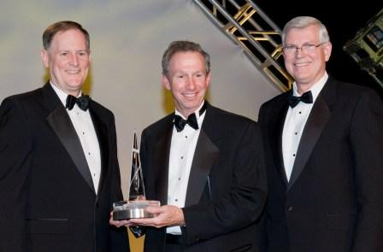RNASA Advisors and former Space Shuttle astronauts Capt. Ken Reightler, now Vice President with Lockheed Martin; and Capt. Michael Coats, currently Director of Johnson Space Center, presented the trophy to Griffin. In keeping with Griffin’s well known use of blunt language, the two provided a candid and humorous review of Griffin’s resume’ and historic quotes. After Reightler recounted Griffin’s six degrees, Coats quipped, “Honestly, Michael, did all that education improve your golf game?”

Then, amid much laughter from the audience, Reightler recalled several of Griffin’s most famous quotes, including one spoken to the Office of Management and Budget in a moment of great frustration; “Don’t tell me how to build a spacecraft, I’m the chief engineer of the universe!”

As is customary at government retirement parties, Coats presented Griffin, his former boss, with a few humorous mementos. He also presented him with a NASA flight jacket that included patches from each of the organizations of the Johnson Space Center, and a NASA patch and American flag that were flown on STS-119. Coats noted, “The name tag also says, Michael D. Griffin, Chief Engineer of the Universe.”

Turning more serious, Reightler and Coats then presented Griffin with the National Space Trophy which the audience approved with a standing ovation.

Accepting the trophy and appearing somewhat embarrassed by all the attention, Griffin said, “Now everyone will understand why I always said I really wanted to do this job [as NASA administrator] anonymously.”

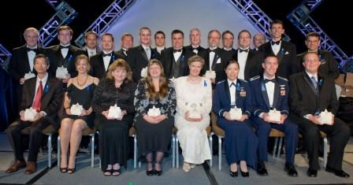Just prior to the trophy presentation, the RNASA Stellar Awards for individuals and teams had been presented by astronauts Leland Melvin and Captain Suni Williams. Griffin congratulated those winners, and predicted, “At least one or two of you are going to be up here some day trying to think of a speech.”

He said the National Space Trophy was not an award he ever expected to receive. “But I’m very grateful for it and very honored to receive it, in this community especially, the home of human spaceflight.” He thanked all the people who were on his team when he was administrator, “for making me look good. I didn’t deserve it, but I appreciated it.” He praised his former deputy administrator, Shana Dale, who was in attendance, and he also thanked all the people that had worked with him in the years past, including former National Space Trophy winners John Young, Glynn Lunney, Chris Kraft, and Gene Kranz.

“I really don’t have the words to say how very much I enjoyed the opportunity to be your administrator; how enormously rewarding I found it. Yes, it fills up your life. It doesn’t leave much room for keeping your golf game sharp … but it was a natural fit for me, and something that I enormously enjoyed.” He noted that he didn’t know who his replacement would be, but said, “I hope that whoever has it will find it within themselves to love the agency and our people and programs and our space enterprises as much as I do.”

Remarking on the recently announced review of NASA by the Obama Administration, he said that reviews are essential to the conduct of technical enterprises, but that there are two kinds of reviews: one that looks at the progress being made; and the other that looks at what the goals should be. “When the review of the space program of the United States is reviewed, I think it will be found to be technically in solid shape—that it’s being led by some of the best people we have in this nation—and yet it is starved for funding. The goals have to be brought into alignment with the funding. One can always change the goals, but I would heartily recommend against that. One could improve the funding. I would heartily recommend that we do that.”

He said that a review of the goals themselves was the wrong kind of review. He praised the new strategic vision for the civil space program that was established and endorsed by the president and congress after the loss of the Space Shuttle Columbia. “That [vision] can live for generations.” He emphasized that “the goals of the space program need to be stable on decadal time periods if the space community is ever to furnish anything in response to those goals. Even a discovery-class mission takes four to five years to accomplish if it’s done well. We can’t change the goals of the human spaceflight program of the United States every few years and ever expect to get a product.”

Noting that Norman Augustine has been tapped to lead the review, Griffin said how much he admired Augustine’s report, “Rising Above the Gathering Storm,” that addressed how the United States is falling behind in higher education compared to other nations. He said “nothing would please me more than to see this latest review highlight the fact that the United States has coasted for 40 years on the lead purchased with the blood sweat and tears and money invested during the Apollo decade, and that it is time to reinvest if we want to maintain pre-eminence on the frontier.”

He concluded by saying that “exploration is the hardest thing we do, but it is the engine which drives all else in society.”

Apollo astronaut Lieutenant General Thomas Stafford then presented Griffin with a special engraved watch on behalf of Omega Watches. Science Applications International Corporation sponsored an original portrait of Griffin by renowned aerospace artist Pat Rawlings that was unveiled at the event and graced the cover of the event’s souvenir program book. It will be displayed with the original trophy at Space Center Houston.

A strong advocate for education, Griffin recently accepted a position as an eminent scholar in engineering and will serve as a professor of mechanical and aerospace engineering with the University of Alabama in Huntsville.

The event was sponsored by: The Aerospace Corporation, ARES Corporation, ATK Launch Systems, Ball Aerospace & Technologies Corp., Barrios Technology, Bastion Technologies, Beacon Associates, Inc., Blackhawk Management Corporation, The Boeing Company, Booz Allen Hamilton Inc., Cimarron, Draper Laboratories, GB Tech, Inc., General Dynamics, Hamilton Sundstrand, Honeywell, Jacobs Engineering, L-3 Communications, Lockheed Martin, ManTech SRS Technologies, Inc., MEI Technologies, Inc., MRI Technologies, National Space Biomedical Research Institute, Northrop Grumman Aerospace Systems, Oceaneering Space Systems, Omega Watches, Orbital Sciences Corporation, Pratt & Whitney Rocketdyne, Science Applications International Corporation (SAIC), SGT, Inc., Tech Trans International, United Space Alliance, University of Houston--Clear Lake, Wyle Laboratories, Inc.

The nonprofit Rotary National Award for Space Achievement (RNASA) Foundation was established by the Space Center Rotary Club of Houston in 1985 to organize and coordinate an annual awards event to recognize outstanding achievements in space and create greater public awareness of the benefits of space exploration. For more information, visit http://www.rnasa.org.

END

